**Yelp Dataset Exploration and Analysis of Reviews**

Archana Date, Apurva Ranade,Vinamratha Kuttagul-Veeresh

Topic Introduction:

Yelp allows its users to share reviews of businesses. For each business, the reviews and star ratings are displayed on each business webpage with an average star rating. Our goal in this project was 1) to improve Yelp’s user experience, by finding a new way of summarizing the ratings and reviews of each business. 2) provide a first step towards the building of convenient tools for Yelp and its users in searching for businesses that meet selection criteria including quality and spatial location, complete with useful visualizations of the data. 3) to generate informative visualizations of insights gained about the reviews of businesses left by users of Yelp.

In this analysis, we made use of data gathered on both businesses and reviews from the services website hosted by Yelp, Inc.  The available data includes six independent datasets, including information on businesses, store check-in durations, user review summaries, tips from users, and info on registered users, and *photos* shared by users. Out of these we exclusively worked with the datasets that described businesses, users, reviews and check-ins.

After pre-processing and cleaning of the data, we made use of text mining and modeling approaches to gather commonly used words appearing across reviews in the database. To better understand the relationships between these words, we used text mining tool to develop visualizations of the relatedness of words, using unsupervised clustering and topic modeling.

PART A - Design

The first step is to create the collections that have indexes/constraints built in them. Here, we create the constraints for collections Business and Reviews.

db.createCollection("business",

{

validator:

{ $and:

[

{ "latitude": { $gte: -90, $lte: 90}},

{ "longitude": { $gte: -180, $lte: 180}}

]

}

}

)

db.createCollection("review",

{

validator:

{ "stars": { $in: [1,2,3,4,5] }

}

}

)

The next step is to present the MongoDB document. There are multiple ways to put together the documents. Given that most queries are going to be centered on the Business and its corresponding Reviews, Tips and Checkins, the most efficient way of presenting the Yelp information is to have one collection for Business with embedding the Reviews, Tips and Checkins within that. To connect this information with Users, a collection reference will be established. Reviewers will be in a separate collection.

**For Business:**

**db.business.insert({**

"_id" **:** ObjectId**(**"5a1311d096678f366051e408"**),**

"business_id" **:** "duHFBe87uNSXImQmvBh87Q"**,**

"name" **:** "Blimpie"**,**

"neighborhood" **:** ""**,**

"address" **:** "4719 N 20Th St"**,**

"city" **:** "Phoenix"**,**

"state" **:** "AZ"**,**

"postal_code" **:** "85016"**,**

"latitude" **:** 33.5059283**,**

"longitude" **:** -112.0388474**,**

"stars" **:** 4.5**,**

"review_count" **:** NumberInt**(**10**),**

"is_open" **:** NumberInt**(**0**),**

"attributes" **:** **{**

"RestaurantsTableService" **:** false**,**

"GoodForMeal" **:** **{**

"dessert" **:** false**,**

"latenight" **:** false**,**

"lunch" **:** false**,**

"dinner" **:** false**,**

"breakfast" **:** false**,**

"brunch" **:** false

**},**

"Alcohol" **:** "none"**,**

"Caters" **:** true**,**

"HasTV" **:** false**,**

"RestaurantsGoodForGroups" **:** true**,**

"NoiseLevel" **:** "quiet"**,**

"WiFi" **:** "no"**,**

"RestaurantsAttire" **:** "casual"**,**

"RestaurantsReservations" **:** false**,**

"OutdoorSeating" **:** false**,**

"BusinessAcceptsCreditCards" **:** true**,**

"RestaurantsPriceRange2" **:** NumberInt**(**1**),**

"BikeParking" **:** true**,**

"RestaurantsDelivery" **:** false**,**

"Ambience" **:** **{**

"romantic" **:** false**,**

"intimate" **:** false**,**

"classy" **:** false**,**

"hipster" **:** false**,**

"divey" **:** false**,**

"touristy" **:** false**,**

"trendy" **:** false**,**

"upscale" **:** false**,**

"casual" **:** false

**},**

"RestaurantsTakeOut" **:** true**,**

"GoodForKids" **:** true**,**

"BusinessParking" **:** **{**

"garage" **:** false**,**

"street" **:** false**,**

"validated" **:** false**,**

"lot" **:** false**,**

"valet" **:** false

**}**

**},**

"categories" **:** **[**

"Sandwiches"**,**

"Restaurants"

**],**

"hours" **:** **{**

"Monday" **:** "10:00-21:00"**,**

"Tuesday" **:** "10:00-21:00"**,**

"Friday" **:** "10:00-21:00"**,**

"Wednesday" **:** "10:00-21:00"**,**

"Thursday" **:** "10:00-21:00"**,**

"Sunday" **:** "11:00-18:00"**,**

"Saturday" **:** "10:00-21:00”

**}**

“review”: [

**{**

"review_id" **:** "6PcJSGUBSLjt4VLXos5C4A"**,**

"user_id" **:** "TLIWzAJPrET0zX4_vgvLhg"**,**

"stars" **:** NumberInt**(**3**),**

"date" **:** "2015-07-11"**,**

"text" **:** "Sometimes the food is spot on and delicious and other times it is quite salty at this location. Very difficult to get a consistently good meal. Menu items add up quickly."**,**

"useful" **:** NumberInt**(**0**),**

"funny" **:** NumberInt**(**0**),**

"cool" **:** NumberInt**(**0**)**

**}]**

**“tips”: [**

**{**

"text" **:** "Get here early enough to have dinner."**,**

"date" **:** "2012-07-15"**,**

"likes" **:** NumberInt**(**0**),**

"user_id" **:** "zcTZk7OG8ovAmh_fenH21g"

**}]**

**“checkins” : [**

**{**

"time" **:** **{**

"Monday" **:** **{**

"12:00" **:** NumberInt**(**1**),**

"1:00" **:** NumberInt**(**1**)**

**},**

"Saturday" **:** **{**

"16:00" **:** NumberInt**(**1**)**

**},**

"Thursday" **:** **{**

"0:00" **:** NumberInt**(**1**)**

**}**

**}**

**} ]**

**“Photos”: [**

**{**

"photo_id" **:** "VZXDC7VBdIXXjE3omVqeMg"**,**

"caption" **:** "Black Angus Steak Sandwich... Huge!!!"**,**

"label" **:** "food"

**}**

**{**

"photo_id" **:** "c6Em6dDZ4aVKDI8Lc2BQog"**,**

"caption" **:** ""**,**

"label" **:** "outside"

**}**

**})**

**For Reviewer:**

**Db.reviewer.insert(**

**{** "_id" **:** ObjectId**(**"5a1311d096678f366051e6c8"**),**

"user_id" **:** "YHJIMK_zVH_VY6HCY6bYvg"**,**

"name" **:** "Erica"**,**

"review_count" **:** NumberInt**(**68**),**

"yelping_since" **:** "2012-06-08"**,**

“nationality” : “United Kingdom”,

"friends" **:** **[**

"Puvuej6lzJ1JOEmtjG7V_Q"**,**

"fq7CL1myWPYeH0d4bKtsIw"**,**

"rAsJznwttFfuxNEe7bTGFA"**,**

"a-Ug_MFryz3utca-NaMkNQ"**,**

"MpPzA3lvp47WRzBohByYlg"

**],**

"useful" **:** NumberInt**(**5**),**

"funny" **:** NumberInt**(**3**),**

"cool" **:** NumberInt**(**1**),**

"fans" **:** NumberInt**(**5**),**

"elite" **:** **[**

NumberInt**(**2016**),**

NumberInt**(**2015**)**

**],**

"average_stars" **:** 4.06**,**

"compliment_hot" **:** NumberInt**(**5**),**

"compliment_more" **:** NumberInt**(**5**),**

"compliment_profile" **:** NumberInt**(**1**),**

"compliment_cute" **:** NumberInt**(**0**),**

"compliment_list" **:** NumberInt**(**0**),**

"compliment_note" **:** NumberInt**(**4**),**

"compliment_plain" **:** NumberInt**(**5**),**

"compliment_cool" **:** NumberInt**(**4**),**

"compliment_funny" **:** NumberInt**(**4**),**

"compliment_writer" **:** NumberInt**(**22**),**

"compliment_photos" **:** NumberInt**(**5**)**

**}**

**Creating Indexes :**

Creating indexes on unique ids in three collections : business, reviews, and users

db.business.createIndex({business_id : 1})

db.reviews.createIndex({review_id : 1})

db.users.createIndex({user_id : 1})

For performing text search, creating text index on ‘Review’ collection to support text search of string content in documents of a collection.

db.reviews.createIndex({text : “text”})

##### Neo4J Graph Data Model

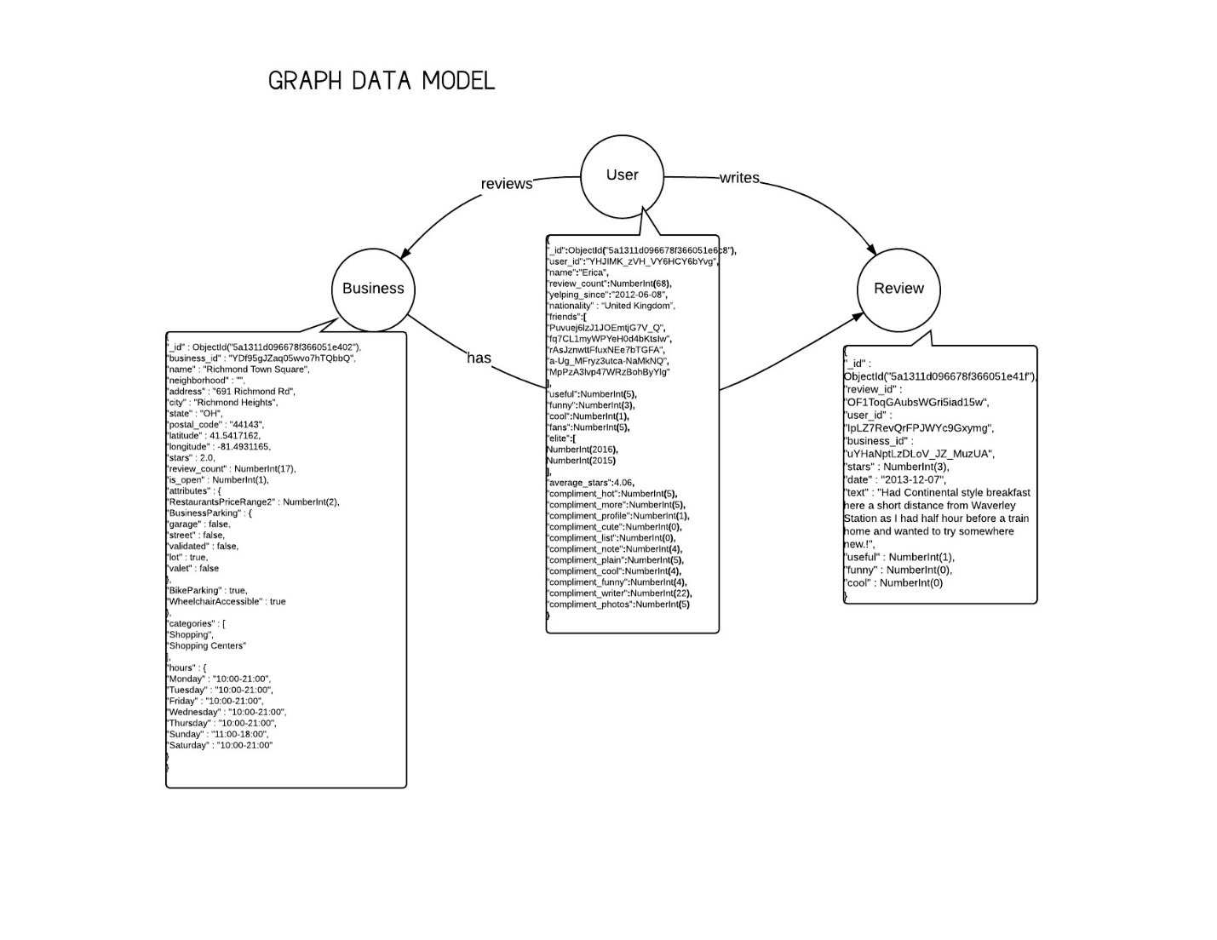

###### PART _ B - Understanding the data

Queries, Summaries and Snapshots

|  |  |
| --- | --- |
| Find number of businesses as part of Restaurants category | Summary |
| db.business.aggregate(  [  { $match: {  categories : "Restaurants"  }  },  {  $group : {    _id : "categories.Restaurants",  count: { $sum: 1 }  }  }  ]  ) | This query finds the number of business in “Restaurant’ category in the dataset.  Using match, Restaurant category is filtered out from the dataset, and count is used to calculate the number of restaurants. |

Snapshot of successful query execution –

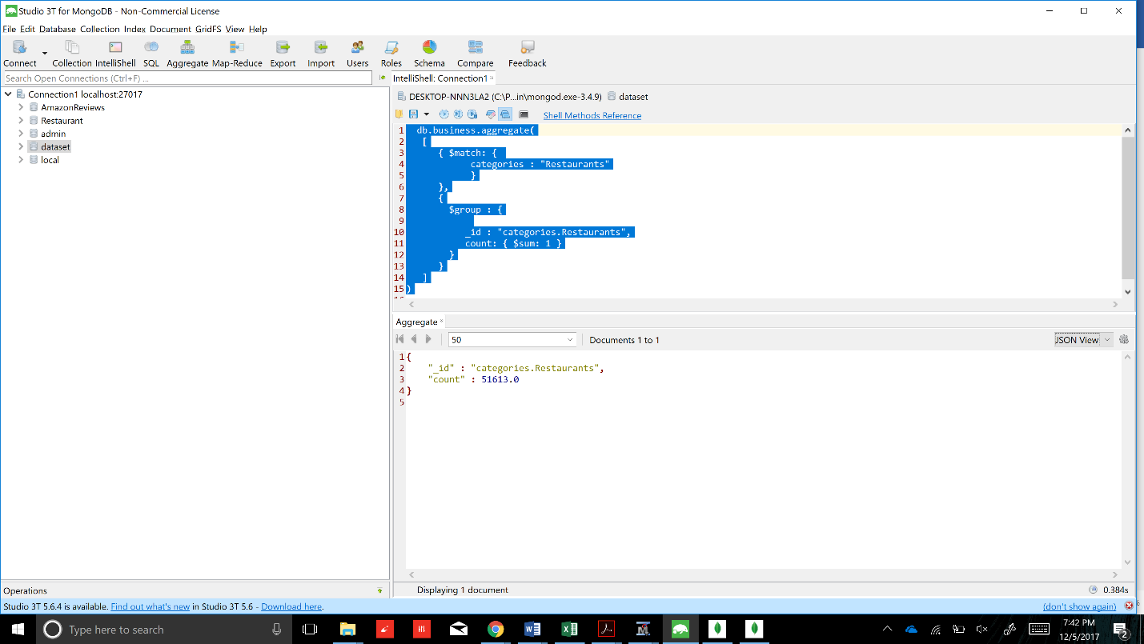

|  |  |
| --- | --- |
| Find number of reviews for each restaurant | Summary |
| db.business.aggregate(  [  { $match: { categories : "Restaurants" }},    {  $project : { _id : 0, business_id : 1, name :1, review_count : 1, stars : 1, state : 1}  },  {$sort:{review_count:-1}}    ]  ) | This query gives the number of reviews for each restaurant  Restaurants are filtered out of all categories using ‘match’, restaurants are sorted in descending order based on review count using ‘sort’. Using ‘project’, the query displays business_id, name of restaurant, it’s rating, state in which restaurant is located, and review count per restaurant. |

Snapshot of successful query execution –

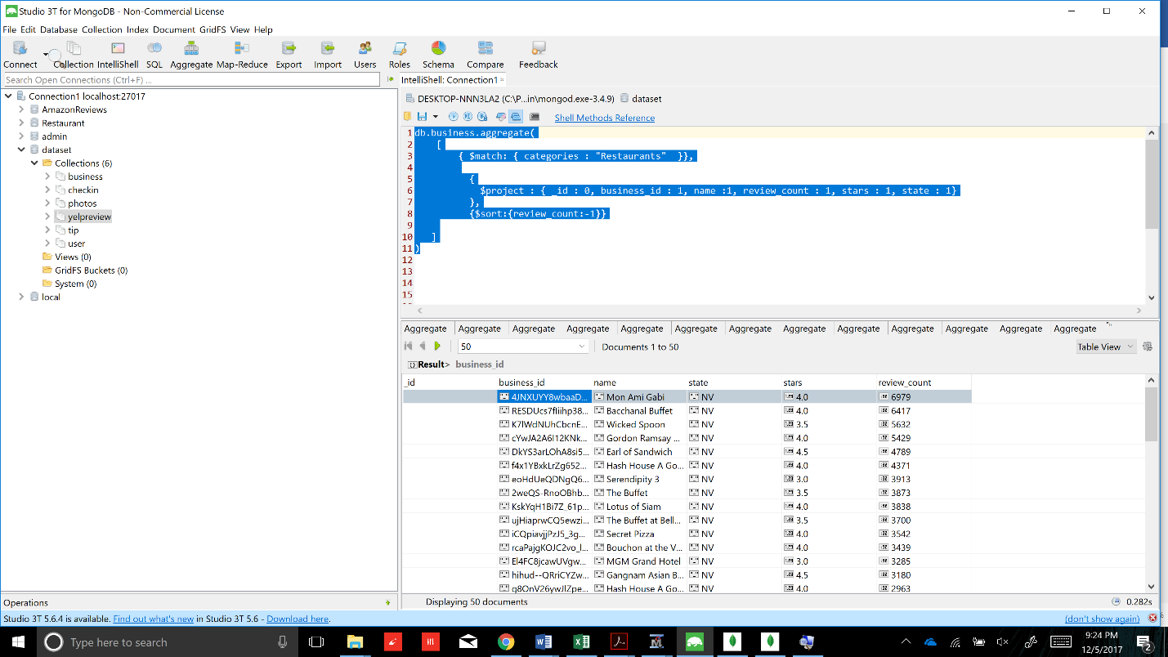

|  |  |
| --- | --- |
| Find avg star rating for top 50 restaurants with most number of reviews | Summary |
| db.business.aggregate(  [  { $match: { categories : "Restaurants" }},      {$sort:{review_count:-1}},  {$limit : 50},  {$group:{"_id":null,"avg":{$avg:"$stars"}}}    ]  ) | This query displays the average rating of top 50 restaurants having maximum number of reviews.  Restaurants are sorted on the basis of maximum reviews by applying sort on review count. 50 restaurants are selected using ‘limit’. These are then grouped together to calculate average of the ratings. |

Snapshot of successful query execution –

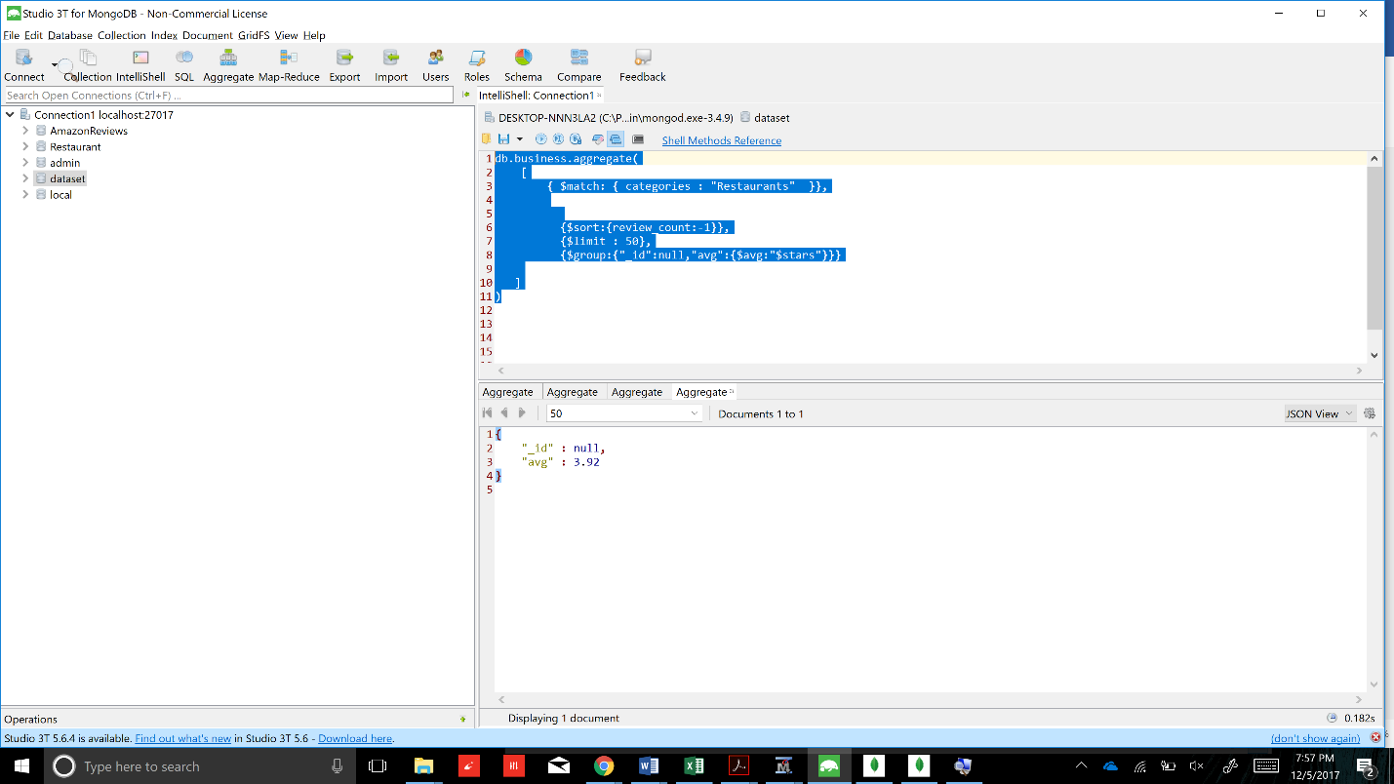

|  |  |
| --- | --- |
| Find the overall number of reviews with ratings less than 3 | Summary |
| db.review.aggregate**([**  **{**$limit **:** 100**},**  **{** $match **:** **{** stars **:** **{**$lt **:** 3 **}}},**  **{** $lookup**:**  **{**  from**:** "business"**,**  localField**:** "business_id"**,**  foreignField**:** "business_id"**,**  as**:** "after"  **}**  **},**  **{**$unwind **:** "$after"**},**  **{**$unwind **:** "$after.categories"**},**    **{** $group **:** **{**"_id" **:** "$after.categories"**,** "total reviews" **:** **{**$sum **:** 1**}}},** **])** | This query gives the overall number of reviews which have ratings less than 3  This query merges the data from two collections – *review* and *business* using ‘lookup’ on the basis of common attribute ‘business_id’. The restaurants having rating less than 3 are filtered using match. These restaurants are grouped on the basis of Category, and total reviews are calculated using ‘sum’ for each category. |

Snapshot of successful query execution –

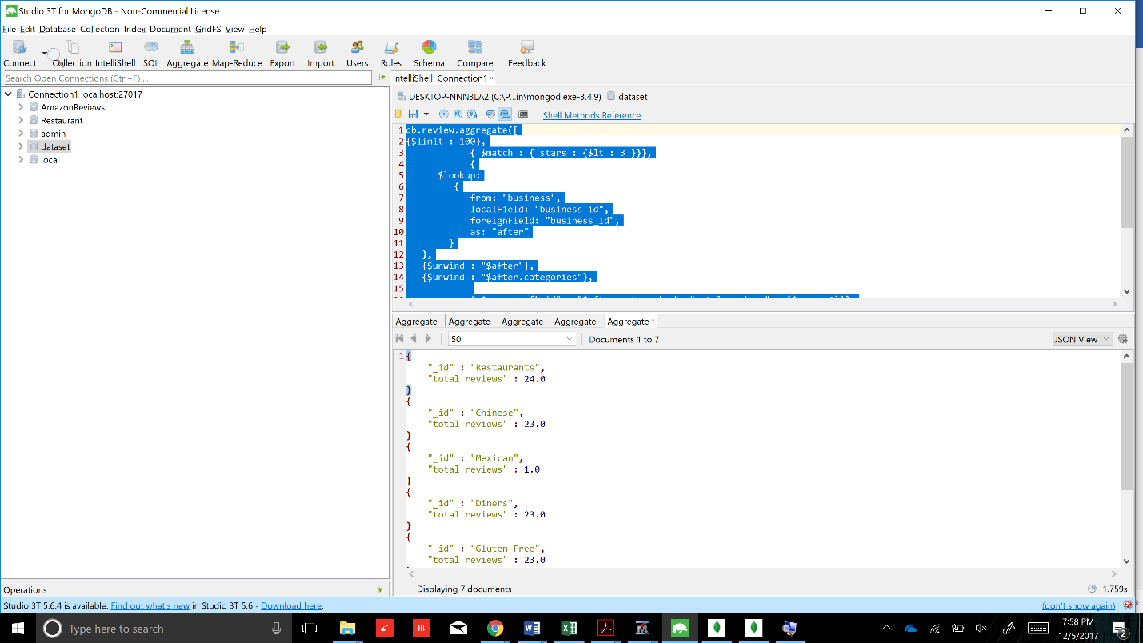

|  |  |
| --- | --- |
| Find the overall number of reviews with ratings greater than or equal to 3 | Summary |
| db.review.aggregate**([**  **{**$limit **:** 100**},**  **{** $match **:** **{** stars **:** **{**$gte **:** 3 **}}},**  **{**  $lookup**:**  **{**  from**:** "business"**,**  localField**:** "business_id"**,**  foreignField**:** "business_id"**,**  as**:** "after"  **}**  **},**  **{**$unwind **:** "$after"**},**  **{**$unwind **:** "$after.categories"**},**    **{** $group **:** **{**"_id" **:** "$after.categories"**,** "total reviews" **:** **{**$sum **:** 1**}}},**  **])** | This query gives the overall number of reviews which have ratings greater than or equal to 3  This query merges the data from two collections – *review* and *business* using ‘lookup’ on the basis of common attribute ‘business_id’. The restaurants having rating greater than or equal to 3  are filtered using match. These restaurants are grouped on the basis of Category, and total reviews are calculated using ‘sum’ for each category. |

Snapshot of successful query execution –

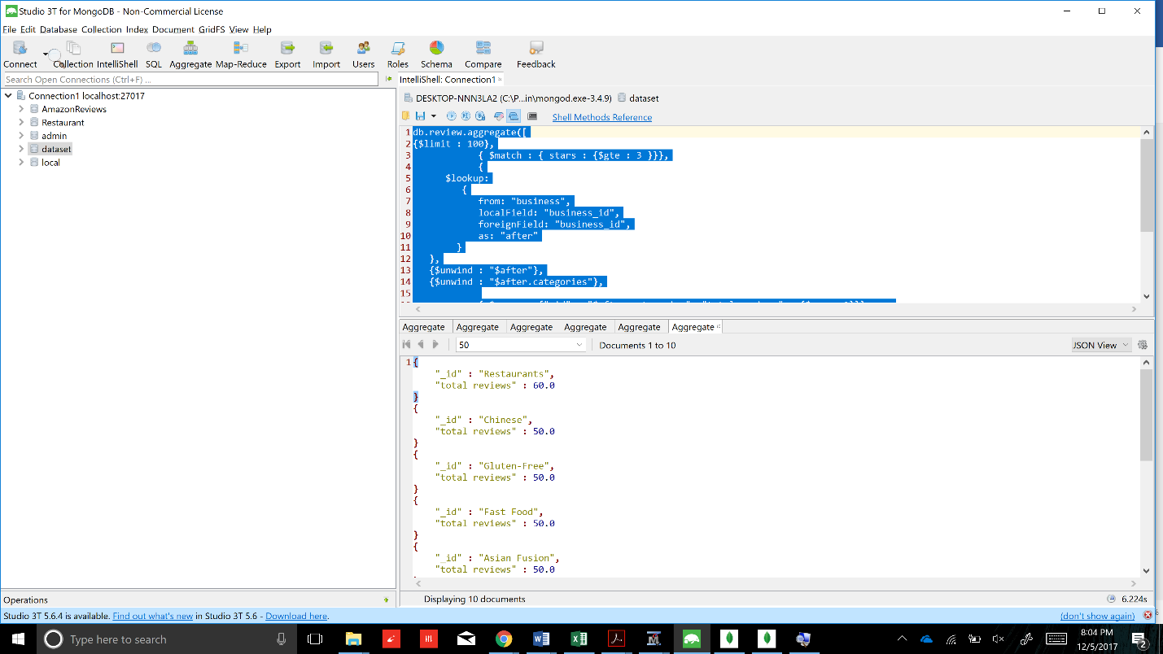

|  |  |
| --- | --- |
| Find the average number of reviews per business | Summary |
| db.business.aggregate([{"$group" : {_id:"$categories.Restaurants" ,  uniqueCount:{$addToSet : "$business_id"},  totalReviews : {$sum : "$review_count"}}},    {$project: {//Category :"categories.Restaurants",  uniqueProductCount:{$size:"$uniqueCount"}, totalReviews : 1,  }},    {$project : { Category :"categories.Restaurants", uniqueProductCount:1,  totalReviews : 1,  avgRevPerBus : {$divide : ["$totalReviews", "$uniqueProductCount"]}}}  ]) | In the business collection, we are grouping based on Restaurants category, the uniqueCount is a set of unique businesses in Restaurant category is taken along with the total number of reviews by summing the review_count column. The size of the set of uniqueCount is stored in iniqueProductCount and displayed in project stage along with category and the total reviews.  In the second project stage, category, number of businesses, number of reviews and avgRevPerBus is calculated using the $divide function. |

Snapshot of successful query execution –

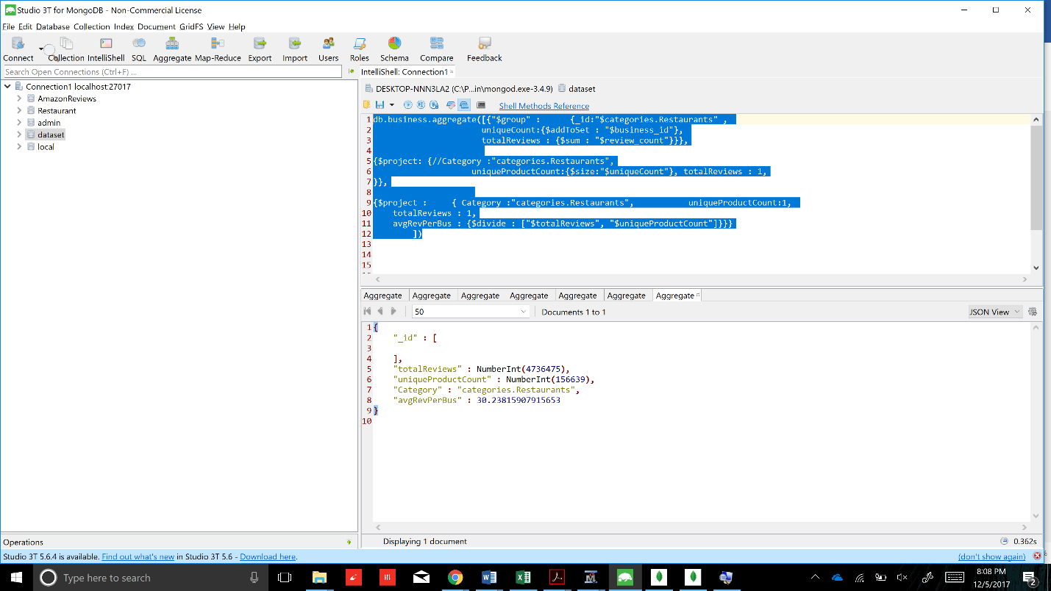

|  |  |
| --- | --- |
| Find number of businesses in each category | Summary |
| db.business.aggregate([  {$unwind: '$categories'},  {$group: {_id: '$categories', count: {$sum: 1}} },  {$sort : {count : -1}}  ]) | This query finds the number of business that are present in every category.  In order to perform operations on ‘Categories’ array, it is unwinded using ‘unwind’. Number of businesses per category has been counted by using ‘count’. It has been sorted in descending order. |

Snapshot of successful query execution –

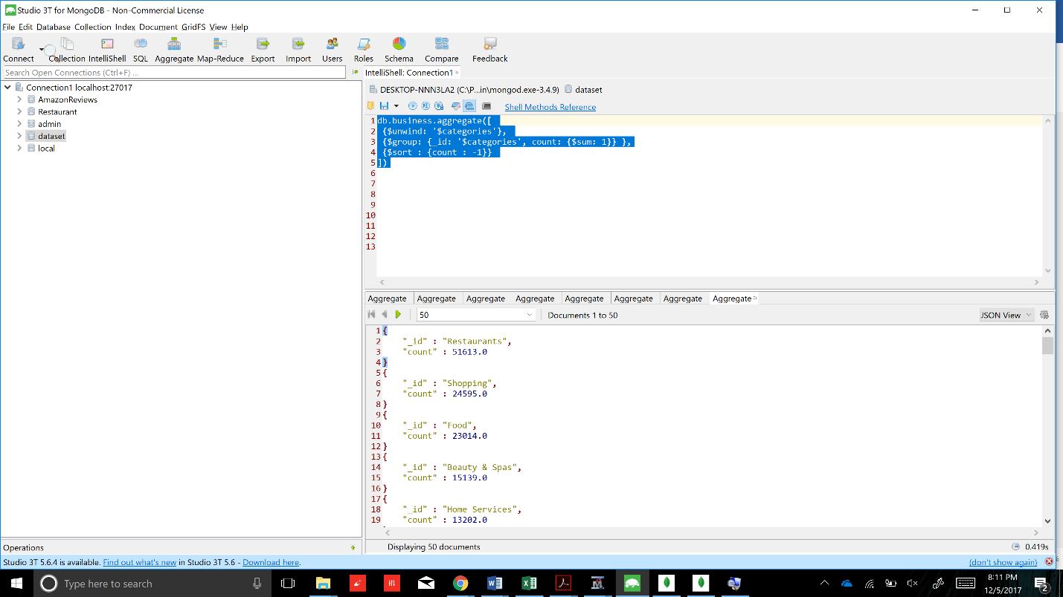

|  |  |
| --- | --- |
| Find oldest review per category | Summary |
| db.business.aggregate([  {$unwind : "$categories"},  {$limit : 50},  {  $lookup:  {  from: "review",  localField: "business_id",  foreignField: "business_id",  as: "after"  }  },  {$unwind : "$after"},  {$group : {_id : "$categories", date : {$min : "$after.date" }}},    ]) | This query finds the oldest review that was given by reviewer for each category.  This query merges the data from two collections – *business* and *review* using ‘lookup’ on the basis of common attribute ‘business_id’. In order to perform operations on ‘Categories’ array, it is unwinded using ‘unwind’, after which oldest review date has been identified using ‘min’. |

Snapshot of successful query execution –

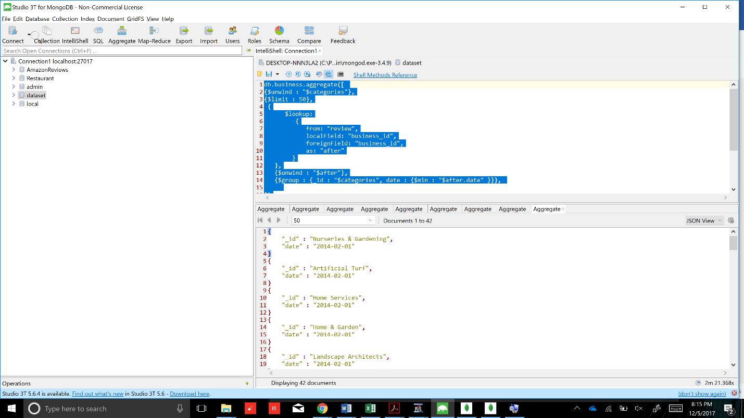

|  |  |
| --- | --- |
| Top 10 most prolific reviewers | Summary |
| db.yelpreview.aggregate([  {$group: {_id:"$user_id", TotalReviews:{$sum:1},}}  ,{$project:{user_id:1,TotalReviews:1}}  ,{$sort:{TotalReviews:-1}}  ,{$limit: 10}  ],{allowDiskUse: true} ) | This query gives 10 users who have written maximum number of reviews.  Total reviews for all the users was calculated by grouping the users by user id and adding reviews per user using ‘sum’. Reviewers who wrote maximum number of reviews were identified by sorting review count in descending order, and 10 reviewers are displayed by putting ‘limit’ on the output. |

Snapshot of successful query execution –

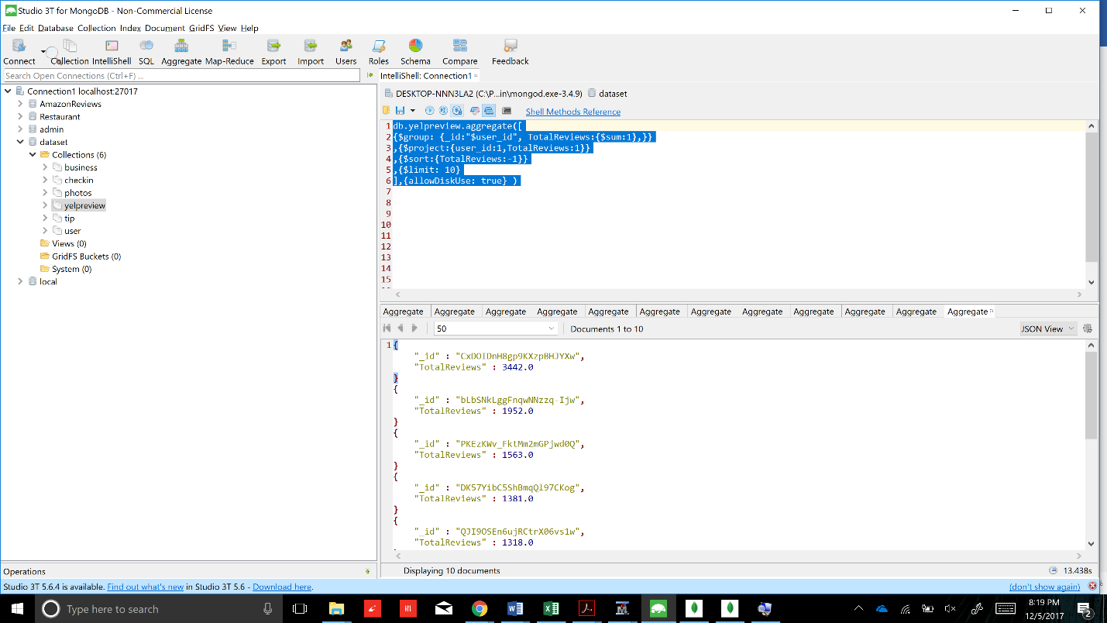

|  |  |
| --- | --- |
| City with max good restaurants | Summary |
| db.business.aggregate([  {$group :  {_id : "$city",  avgRating : {$avg : "$stars"},  numberOfBusinesses : {$push : "business_id"},  state : {$first:"$state"}  }},  {$project :  { _id : 1,  avgRating : 1,  numberOfBusinesses : {$size : "$numberOfBusinesses"},  state : 1  }},  {$match : {  numberOfBusinesses : {$gt : 100},    }},  {$sort : {avgRating : -1}}  ]) | In the business collection, first the documents are grouped by city and average rating of the cities, the state and a list of businesses are taken.  In the project part, the city, avgRating and the count of the businesses and its state are displayed.  We are then restricting the cities with greater than 100 businesses. Next the documents are sorted by avgRating in descending order. |

Snapshot of successful query execution –

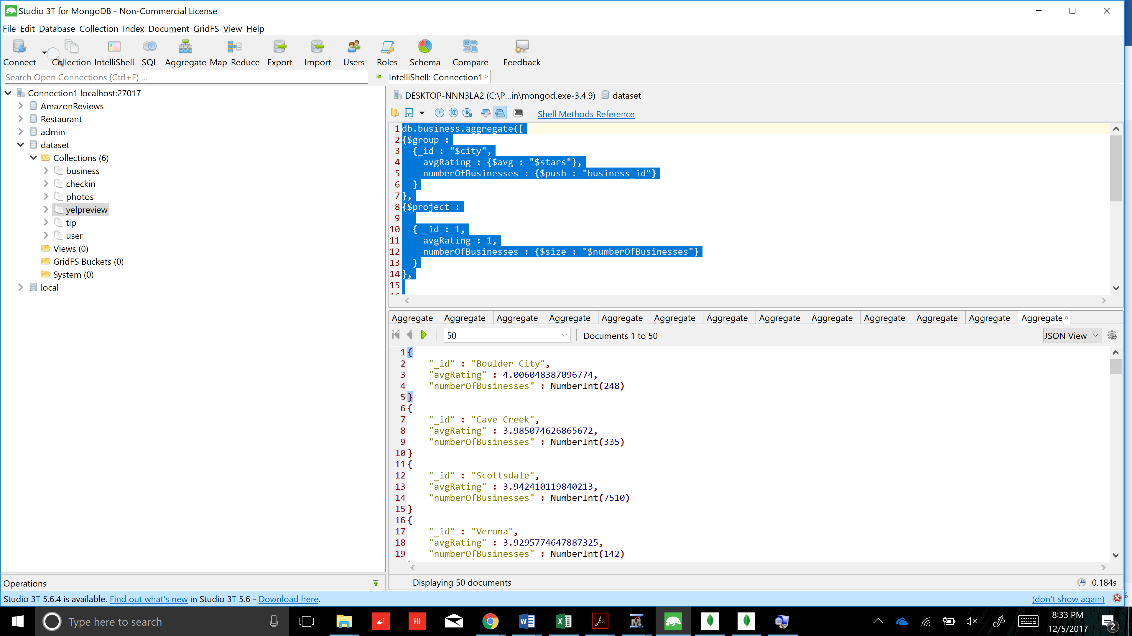

|  |  |
| --- | --- |
| Find top 10 restaurants with highest number of reviews | Summary |
| db.review.aggregate**([**  **{**$match **:** **{** business_id **:** "4JNXUYY8wbaaDmk3BPzlWw"**}},**  **{**$sort **:** **{**date **:** 1**}},**  **{**$limit **:** 100**},**  **{**$group **:** **{**_id **:** "$stars"**,** count **:** **{**$sum **:** 1**}}},**  **])** | In the review collection, documents of 1 business_id are matched as we are looking at recent ratings of a particular business. It is then sorted by date, the most recent on top. The documents are lited to 100 by using limit and the grouped by stars and counted. |

Snapshot of successful query execution –

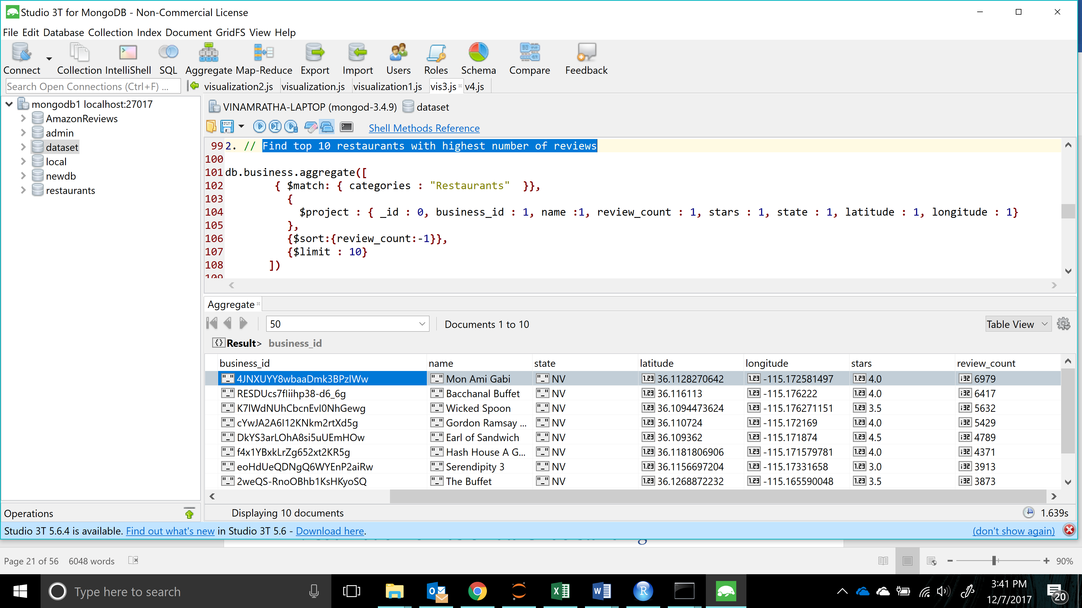

Visualization for Basic Data Understanding

1. This graph shows that the category with highest number of businesses is Restaurants, then Shopping, Food, etc. The different categories are color coded in the legend and the size of the circle represents the number of businesses.

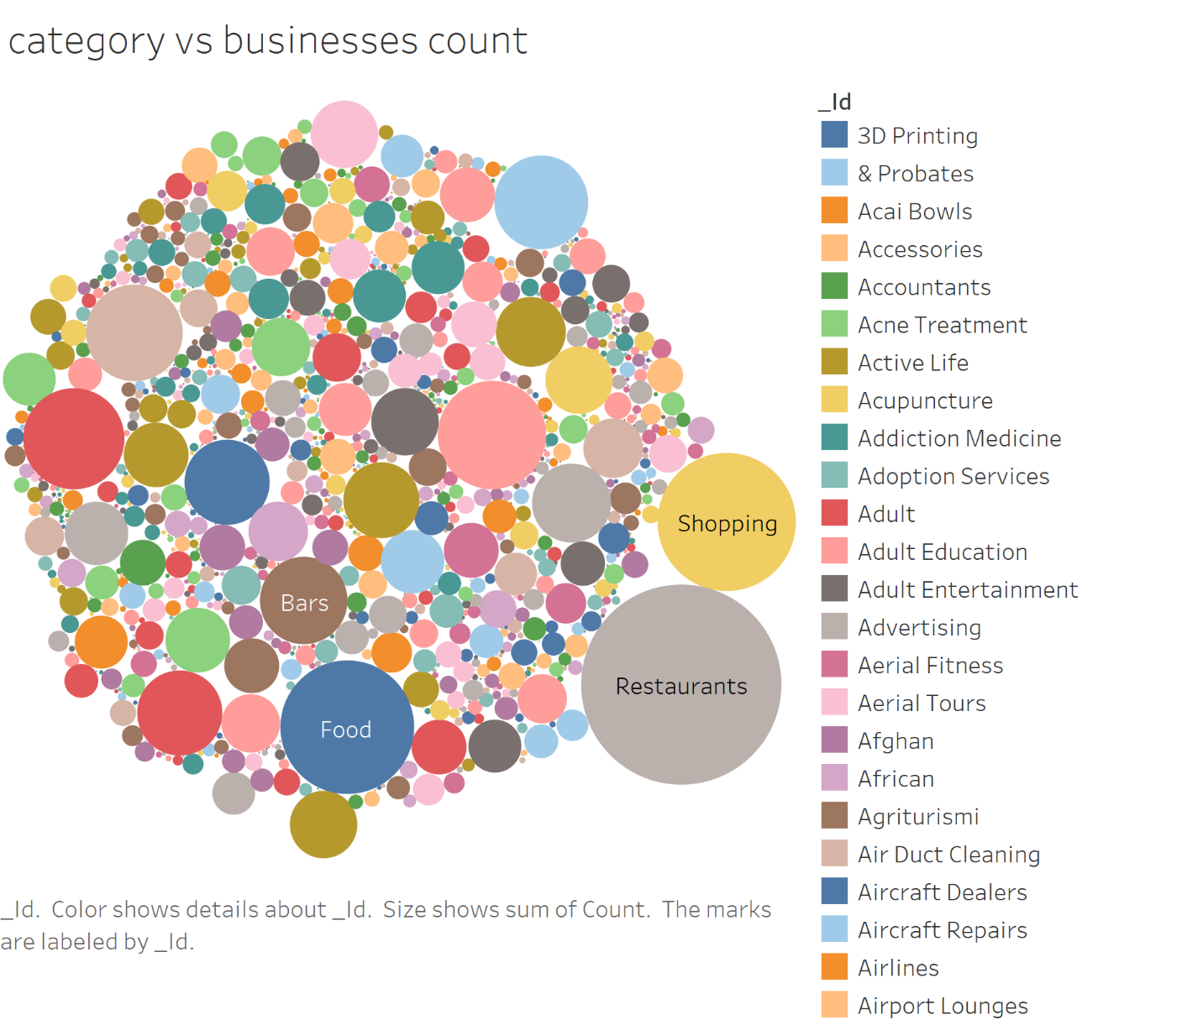

1. The below bar chart shows the top 8 cities with highest avg rating for Restaurants. The constraint we had added is that we considered cities with more than 5000 restaurants. Las Vegas has highest number of restaurants in the top 8 but Scottsdale has the highest avg rating as shown in the line graph.

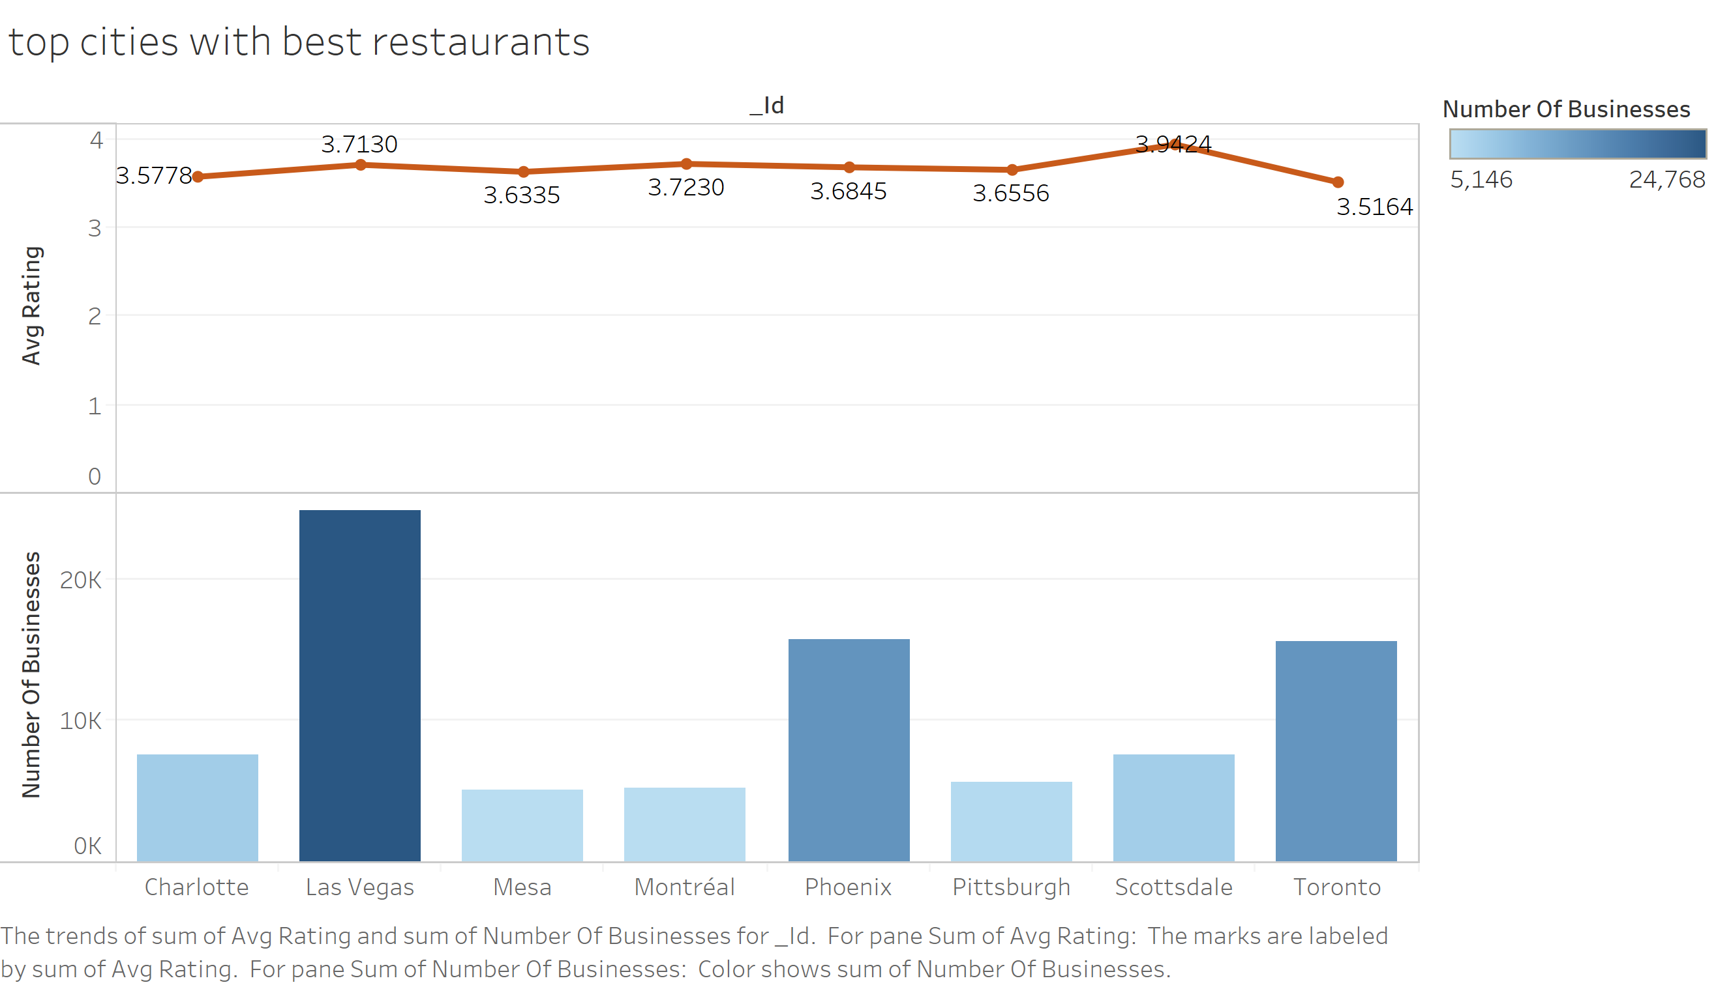

1. The below chart represents the top 10 restaurants with the highest number of ratings. The shape and colour of the markers represent different restaurants . We can see that these restaurants with highest reviews have ratings above 3.

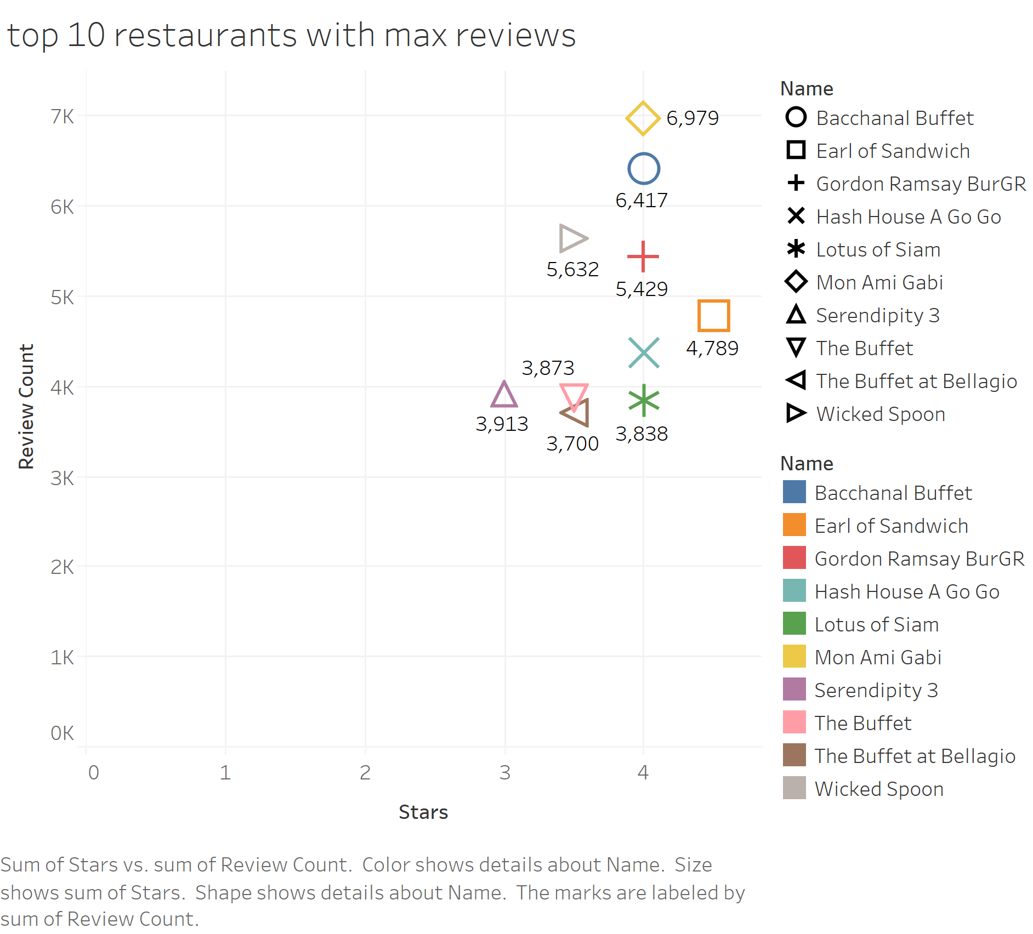

1. This is an interesting graph which shows the number of businesses having less than 3 ratings and the number of businesses having greater than or equal to 3 rating. As you can see, the shape of the graphs are almost same indicating that the positive and negative ratings are evenly distributed across categories.

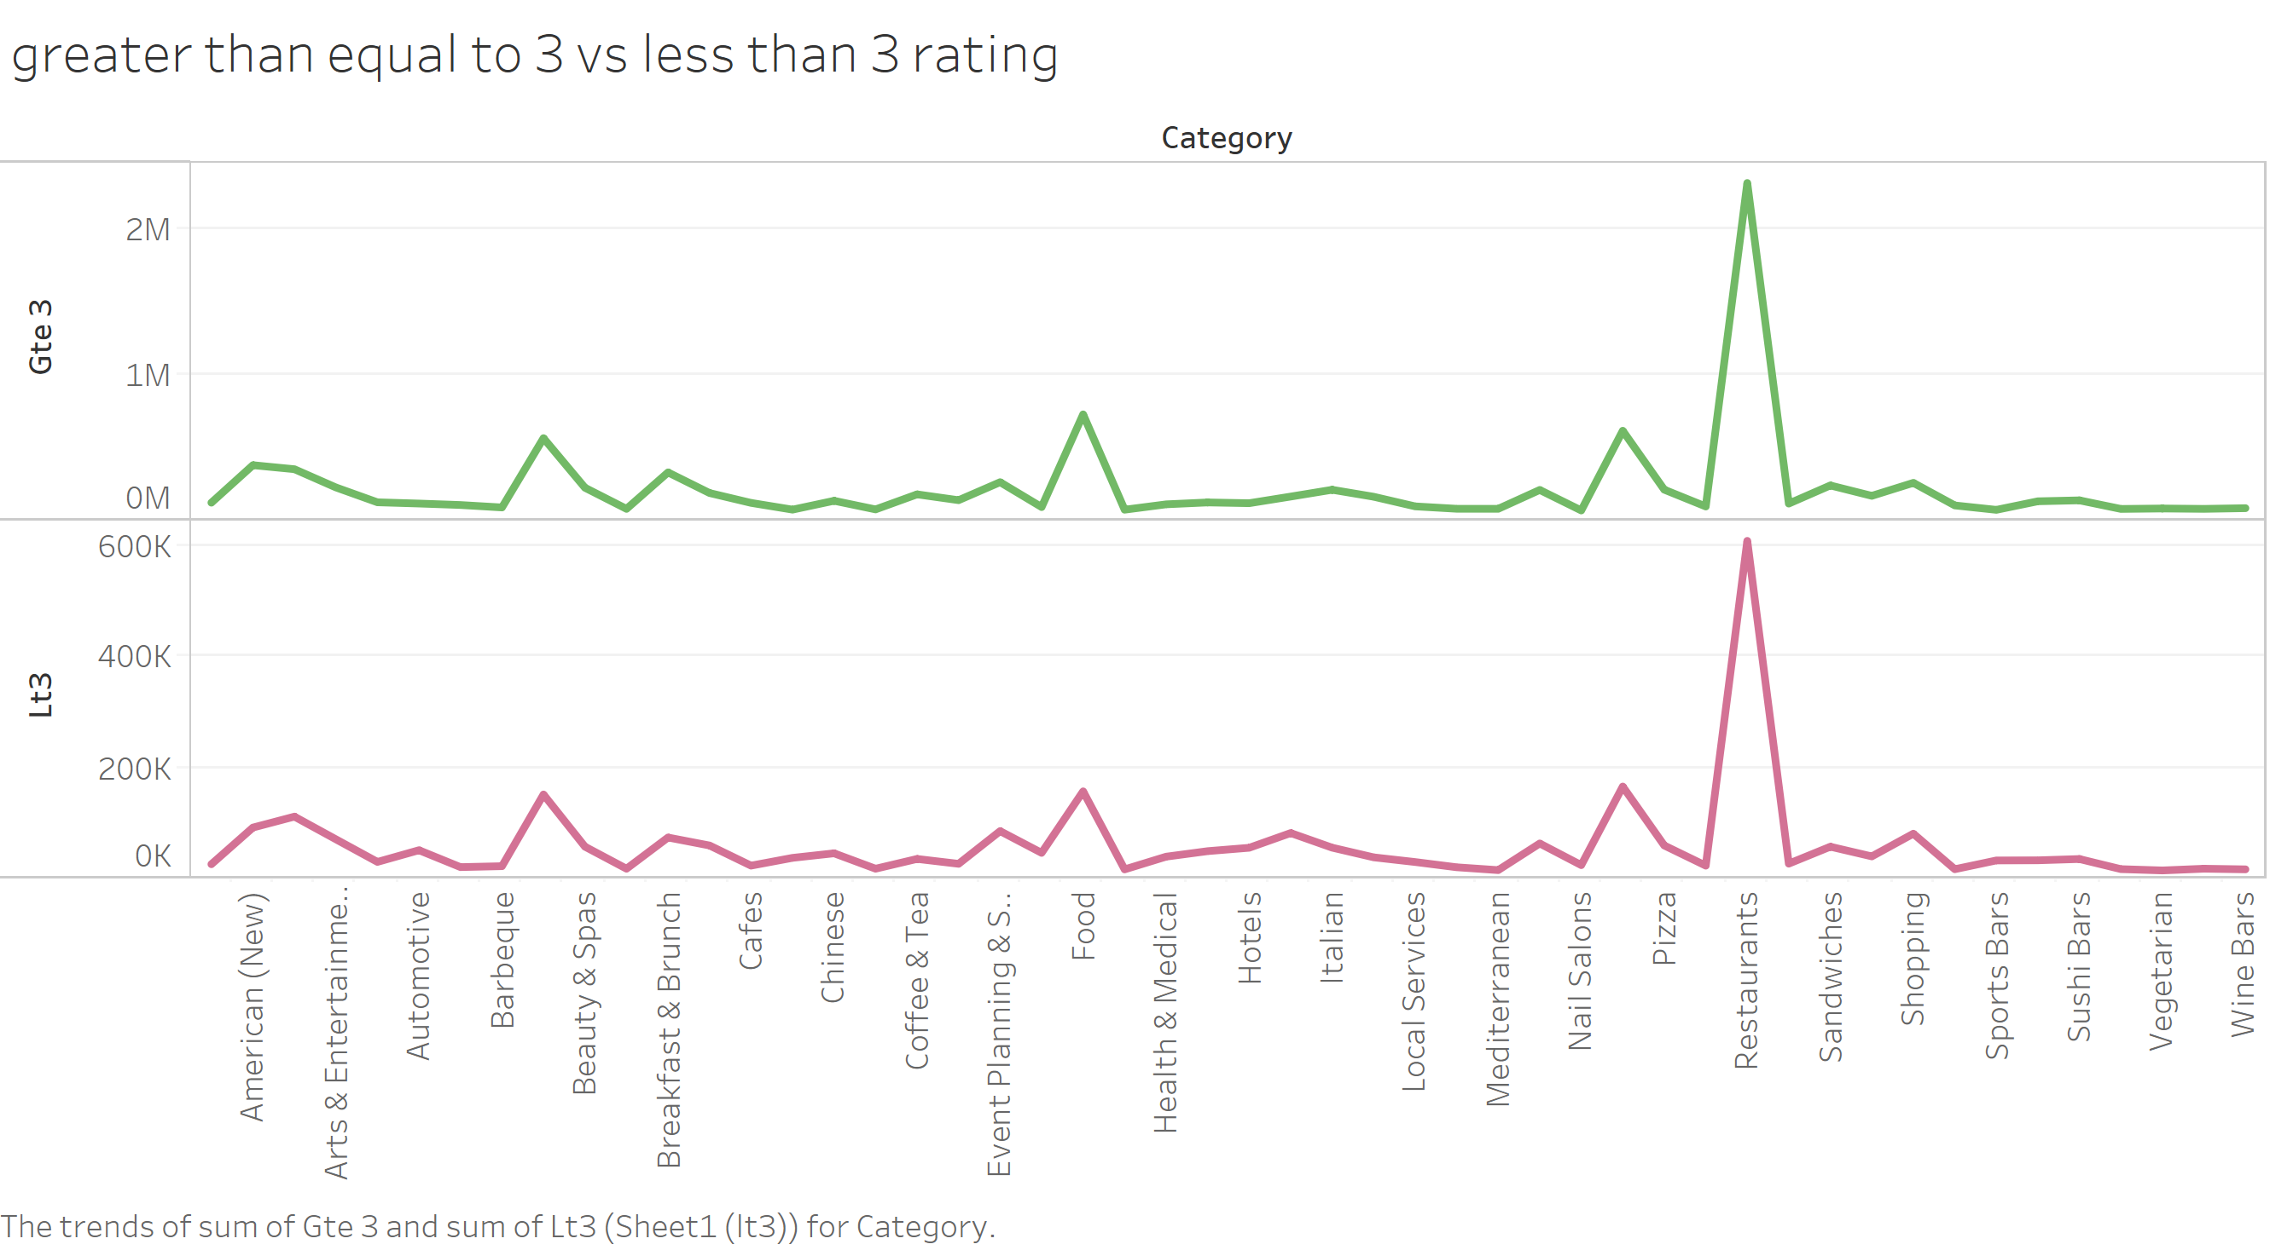

Part C - Analytical Metrics for Improvements

### Using MongoDB – Queries, Summary and Snapshots

|  |  |
| --- | --- |
| Compare ratings of restaurants in my neighborhood in my price range | Summary |
| db.business.aggregate**(**  **{**$match **:{**$and**:[**  **{**categories**:{**$in**:[**"Restaurants"**]}},**    **{**review_count**:{**$gt**:**100**}},**  **{**"attributes.RestaurantsPriceRange2"**:{**$gte**:**2**}},**  **{**stars **:** **{**$gte **:** 0**}},**  **{**neighborhood **:** "The Strip"**}**  **]}},**  **{**$group **:** **{** _id **:** "$stars"**,**  count**:** **{** $sum**:** 1 **}}})** | From business collection documents containing categore Restaurants and having review_count greater than 100 are matched. Less review count skews the data. The price range of greater than 2 are matched with all star rating and in the Las Vegas neighborhood : “The Strip”.  Then the matched documents are grouped by stars and the number of documents are counted. |

Snapshot of successful query execution –

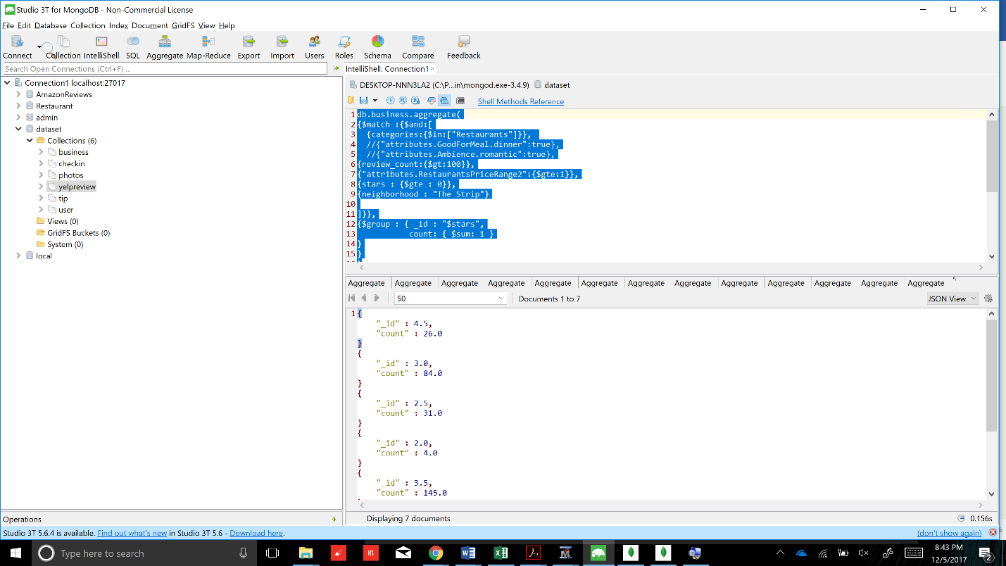

|  |  |
| --- | --- |
| For a city, which neighborhood has maximum number of good restaurants | Summary |
| db.business.aggregate**([**  **{**$match **:** **{**stars **:** **{**$gt **:** 3**},** city **:** "Las Vegas"**}},**  **{**$group **:**  **{** _id **:** "$neighborhood"**,**  goodRestaurants **:** **{**$push **:**"$business_id"**},**  city **:{**$first **:** "$city"**},**  **}},**    **{**$project **:** **{** _id **:** 1**,** countGood **:** **{** $size **:** "$goodRestaurants"**},** city **:** 1**}},**    **{**$sort **:** **{**countGood **:** -1**,** city **:** 1**}}**  **])** | First the documents with city “Las Vegas “ and rating of 4 and 5 only are matched. Then the documents are grouped by “neighborhood”. A list called “good restaurants” is created containing the business_ids according to the neighborhood.  Then in project stage, the neighborhood, count of the list “good restaurants” and city are displayed after sorting on countGood in descending and city in alphabetical order. |

Snapshot of successful query execution –

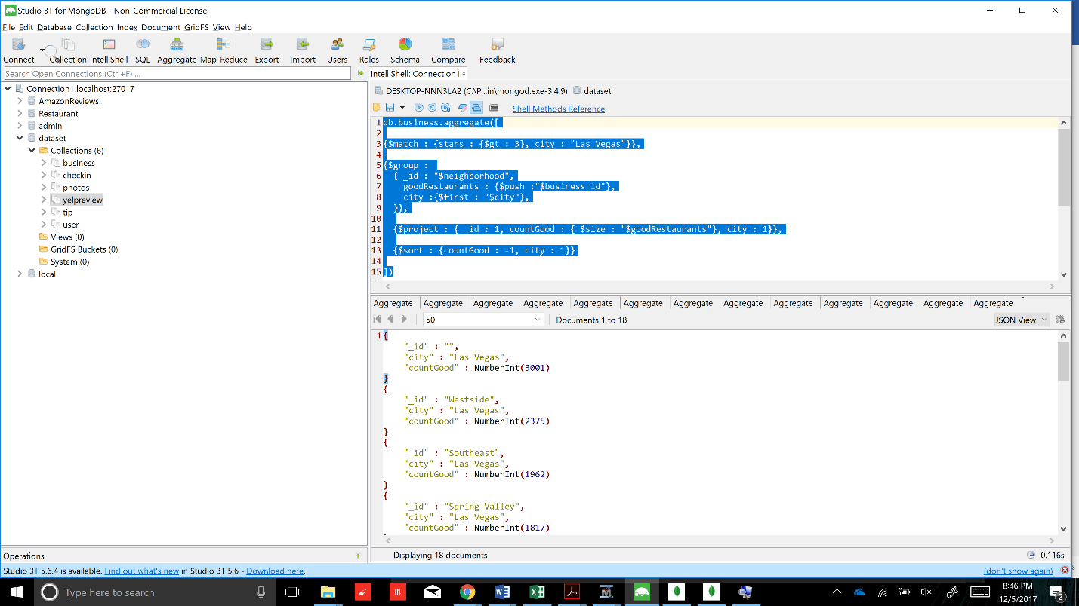

|  |  |
| --- | --- |
| Recent 100 reveiws rating for a business | Summary |
| db.review.aggregate**([**  **{**$match **:** **{** business_id **:** "4JNXUYY8wbaaDmk3BPzlWw"**}},**  **{**$sort **:** **{**date **:** 1**}},**  **{**$limit **:** 100**},**  **{**$group **:** **{**_id **:** "$stars"**,** count **:** **{**$sum **:** 1**}}},**  **])** | In the review collection, documents of 1 business_id are matched as we are looking at recent ratings of a particular business. It is then sorted by date, the most recent on top. The documents are lited to 100 by using limit and the grouped by stars and counted. |

Snapshot of successful query execution –

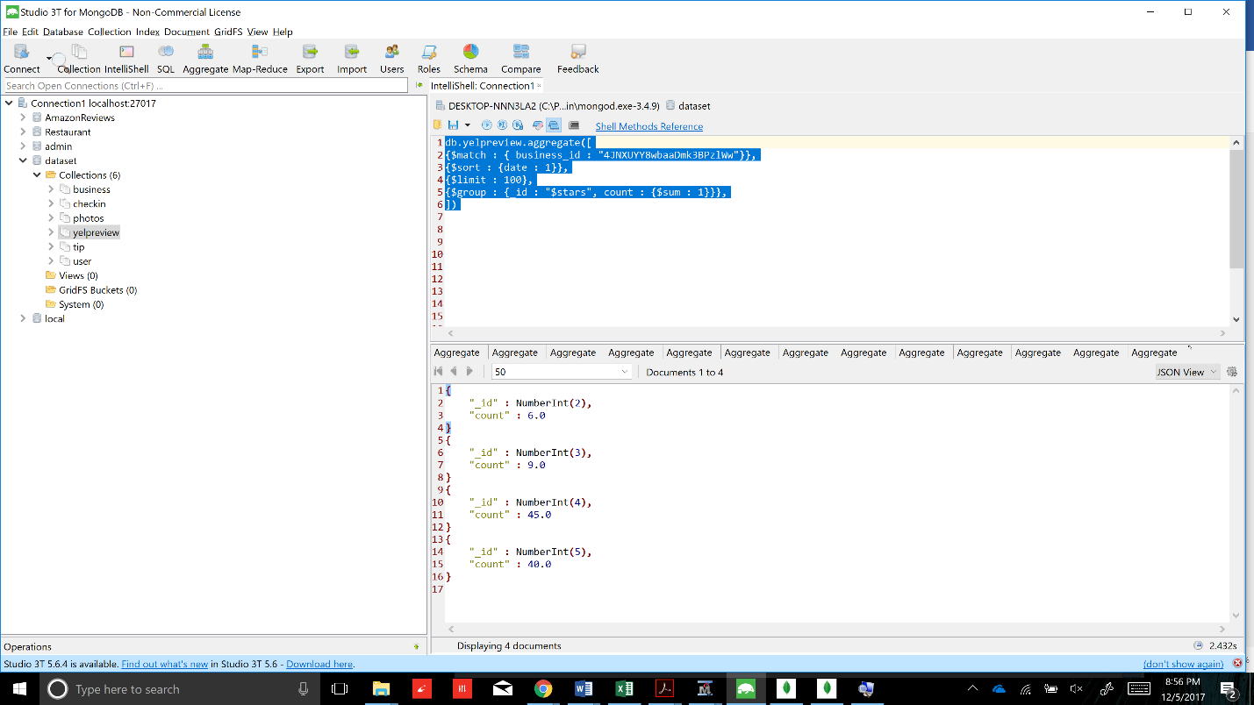

|  |  |
| --- | --- |
| Query for Checkin data for a business | Summary |
| db.checkin.aggregate**([**  **{**$match **:** **{**"business_id" **:** "4JNXUYY8wbaaDmk3BPzlWw"**}},**  **{**$unwind **:** "$time"**},**  **{**$group **:** **{** _id **:** "$time"**,** count **:{** $sum **:** 1**}}},**  **])** | From checkin collection, business_id is matched and time is unwound using $unwind and displayed the count. |

Snapshot of successful query execution –

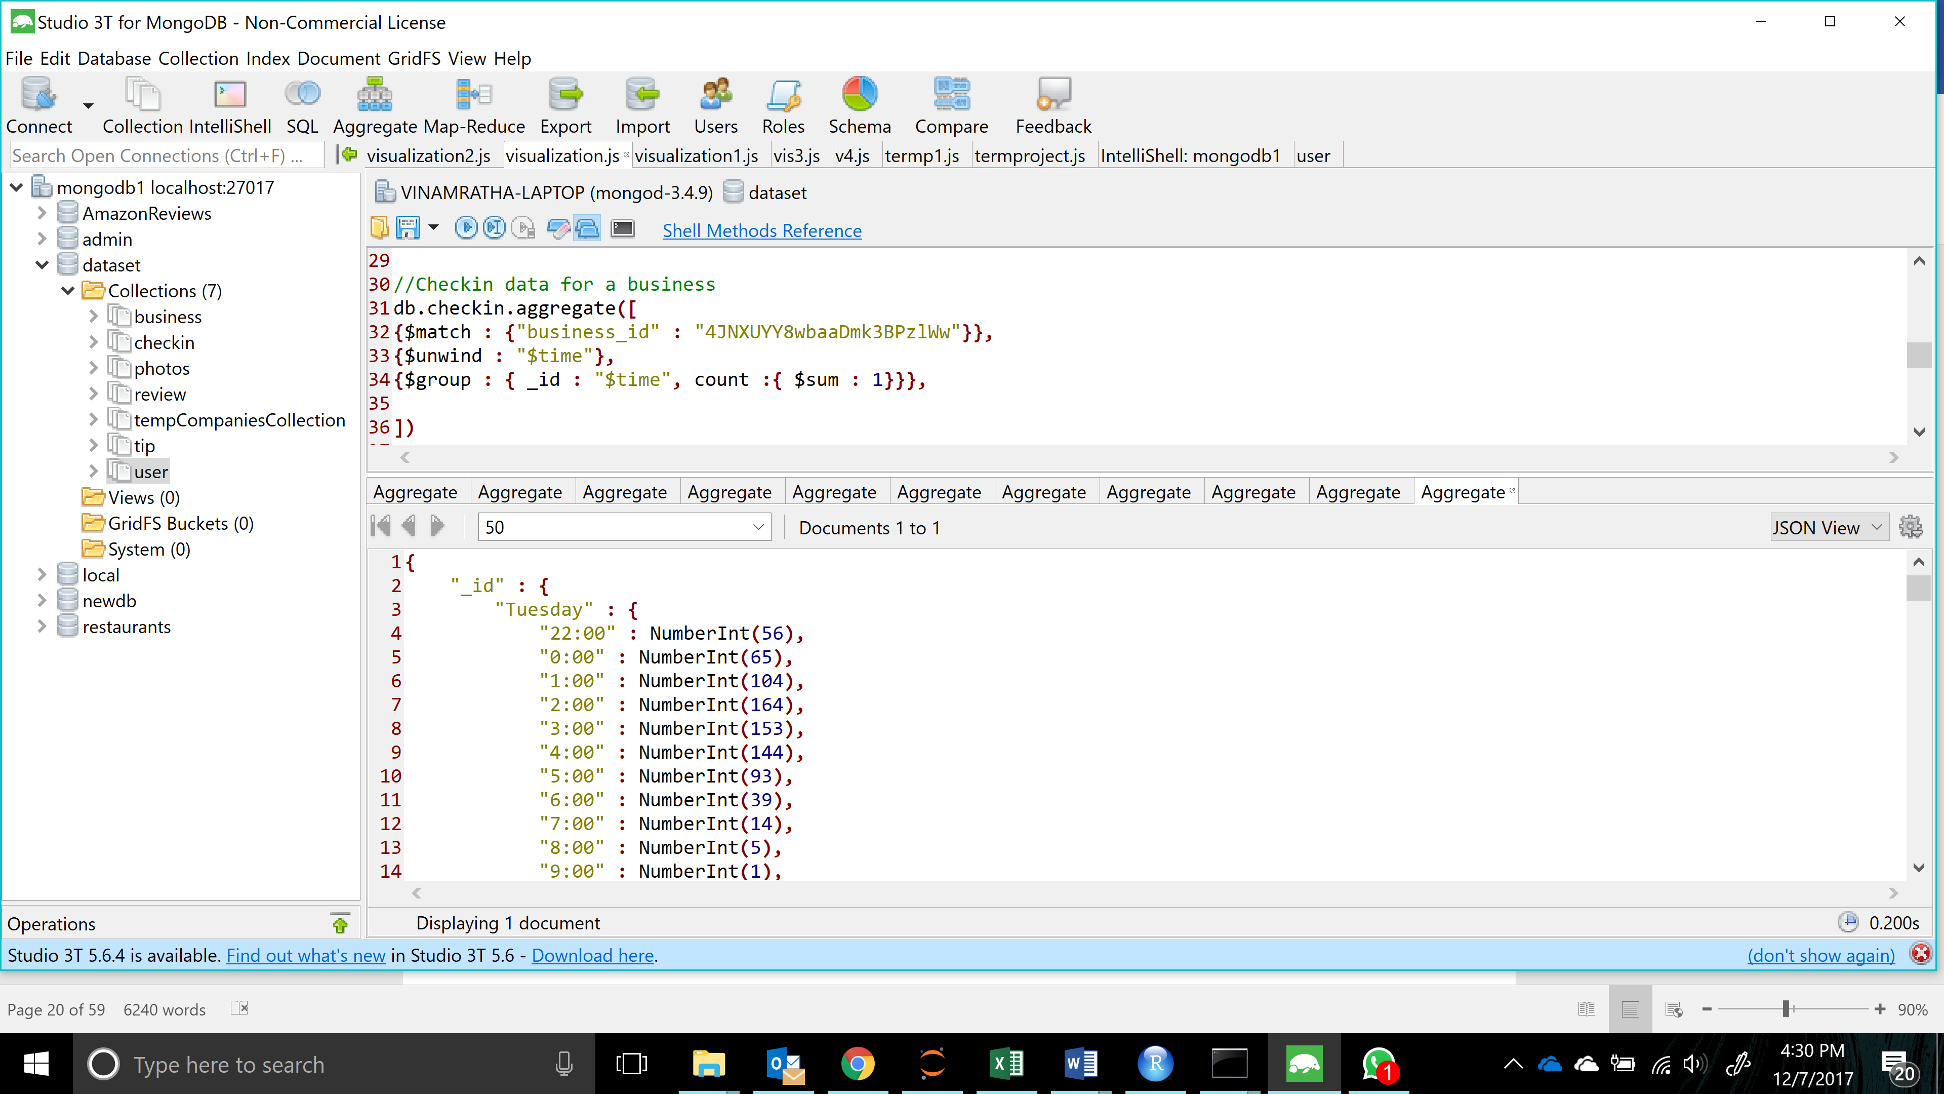

|  |  |
| --- | --- |
| Past 6 months rating trend for a business | Summary |
| db.review.aggregate**([**  **{**$match **:** **{**business_id **:** "PV9CdNFDOX4_zWm3Sy3W8g"**,**  date **:** **{**$lt **:** "2017-07-31"**,** $gte **:** "2017-02-01" **}**  **}},**  **{**$group **:**  **{**_id **:** **{**$substr**:** **[**"$date"**,** 5**,** 2**]},**  avgRating **:** **{**$avg **:** "$stars"**}**  **}**  **},**  **{** $project**:** **{**  _id**:** 0**,**  month**:** "$_id"**,**  avgRating**:** 1**,**    **}**  **},**  **{**$sort **:** **{**month **:** -1**}}**  **])** | Frpm review collection, business_id of a business is matched. The $substr is used to get the month and month, avg rating is displayed. Sorted by month in ascending order. |

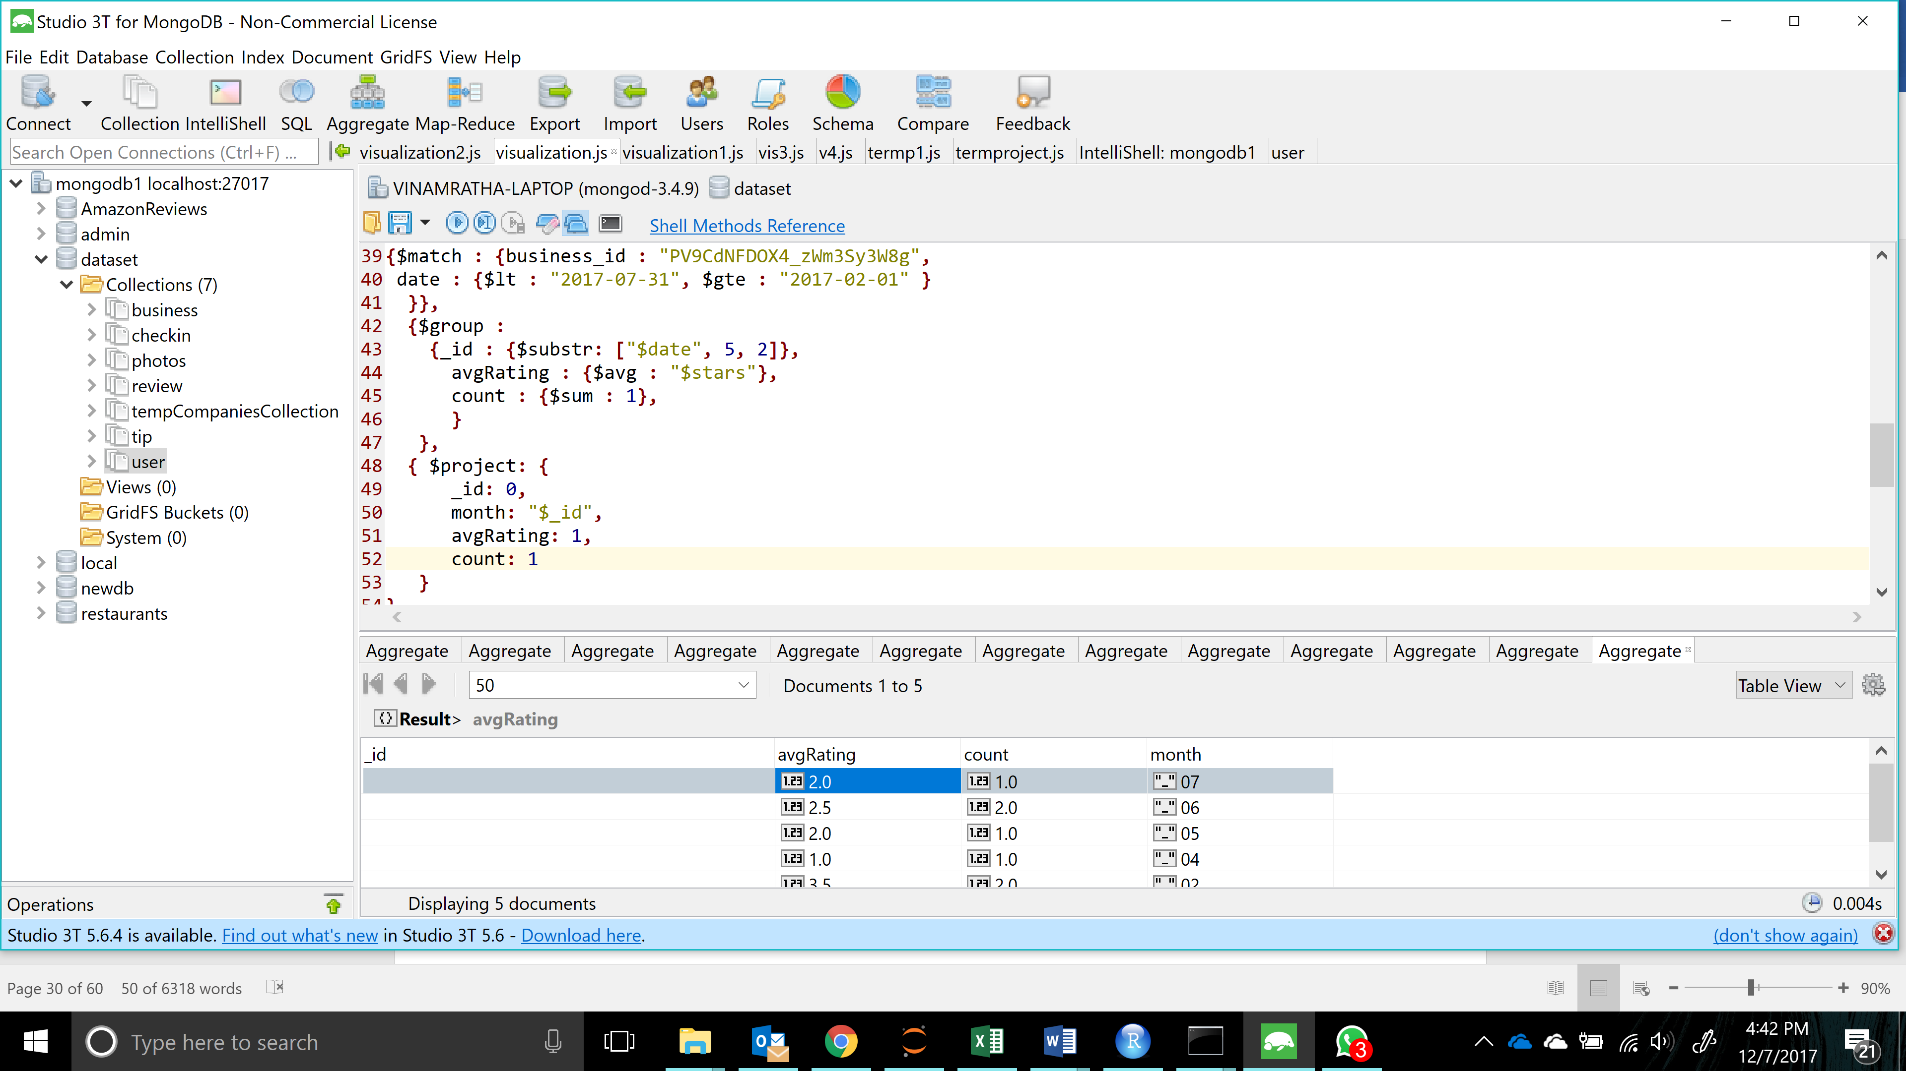

|  |  |
| --- | --- |
| Year wise trend of a reviewer | Summary |
| db.review.aggregate**([**  **{**$match **:** **{**user_id **:** "nzsv-p1O8gCfP3XijfQrIw"**,**    **}},**  **{**$group **:**  **{**_id **:** **{**$substr**:** **[**"$date"**,** 0**,** 4**]},**  avgRating **:** **{**$avg **:** "$stars"**},**  count **:** **{**$sum **:**1**}**  **}**  **},**  **])** | From the review collection, the user_id is matched for specific reviewer and $substr is used to get the year and grouped by year. Abg rating and count are displayed. |

Snapshot of successful query execution –

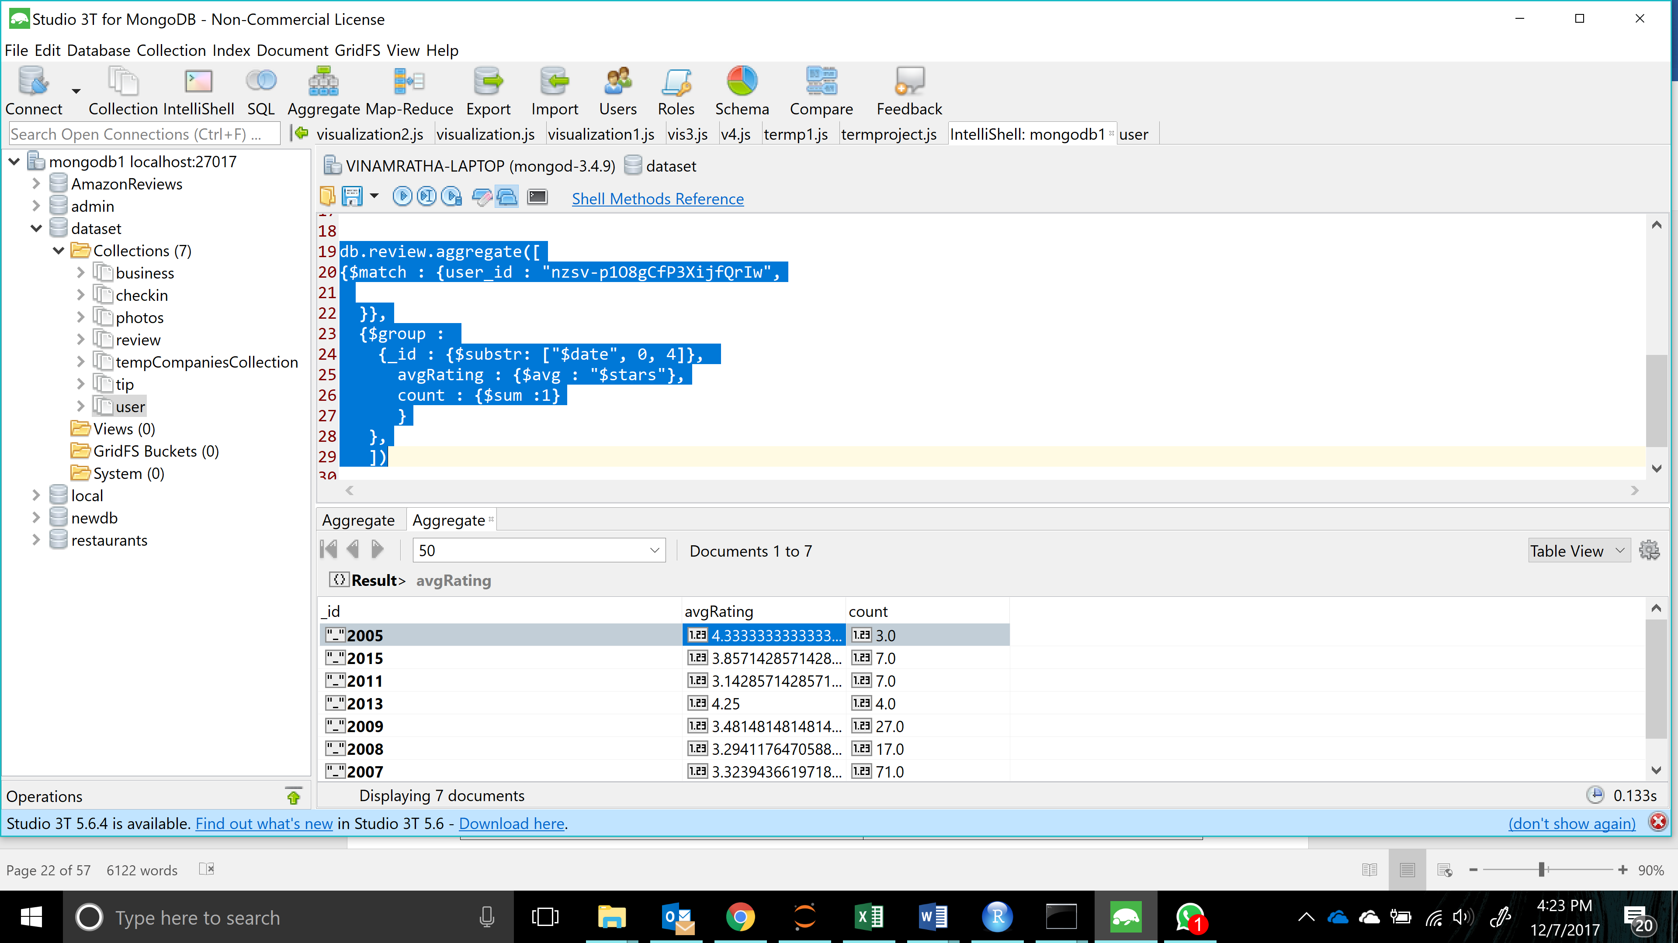

|  |  |
| --- | --- |
| reviews trend for a reviewer - count , avg rating and category | Summary |
| db.review.aggregate**([**  **{**$match **:** **{** user_id **:** "om5ZiponkpRqUNa3pVPiRg"**}},**  **{**$sort **:** **{**date **:** 1**}},**  **{**  $lookup**:**  **{**  from**:** "business"**,**  localField**:** "business_id"**,**  foreignField**:** "business_id"**,**  as**:** "after"  **}**  **},**  **{**$unwind **:** "$after"**},**  **{**$unwind **:** "$after.categories"**},**  **{**$group **:** **{**_id **:** "$after.categories"**,** count **:** **{**$sum **:** 1**},** avgRating **:** **{**$avg **:** "$stars"**}}},**  **])** | The collections review and business are merged and the result is unwound using $unwind. Then categories is unwound. Categories wise avg rating and count are frouped and displayed. |

Snapshot of successful query execution –

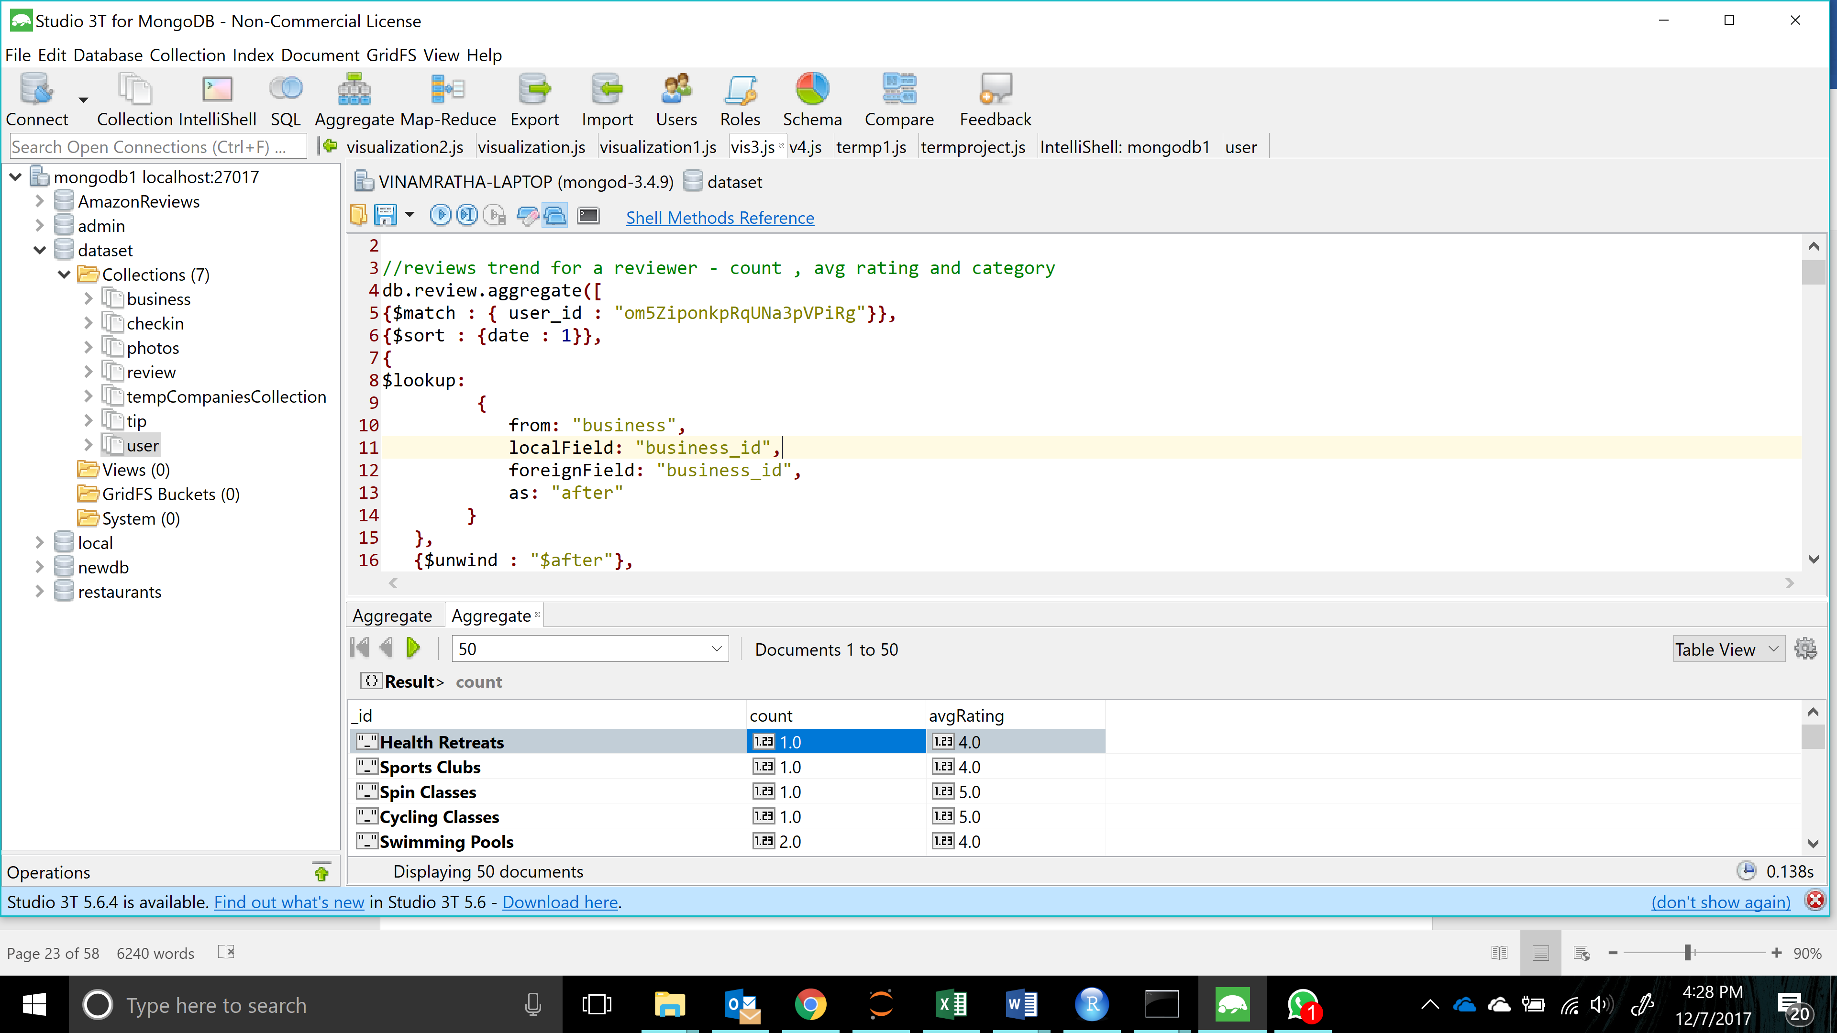

|  |  |
| --- | --- |
| Useful review count category wise for a reviewer | Summary |
| db.review.aggregate**(**  **[**  **{**  $match**:** **{**  user_id **:** "om5ZiponkpRqUNa3pVPiRg"  **}**  **},**  **{**  $lookup**:**  **{**  from**:** "business"**,**  localField**:** "business_id"**,**  foreignField**:** "business_id"**,**  as**:** "after"  **}**  **},**  **{**$unwind **:** "$after"**},**  **{**$unwind **:** "$after.categories"**},**  **{** $group **:** **{**"_id" **:** "$after.categories"**,** "total reviews" **:** **{**$sum **:** 1**},** **}},**      **]**  **)** | The two collections review and business are merged using $lookup. After unwinding categories, the documents are grouped according to categories and the useful count. |

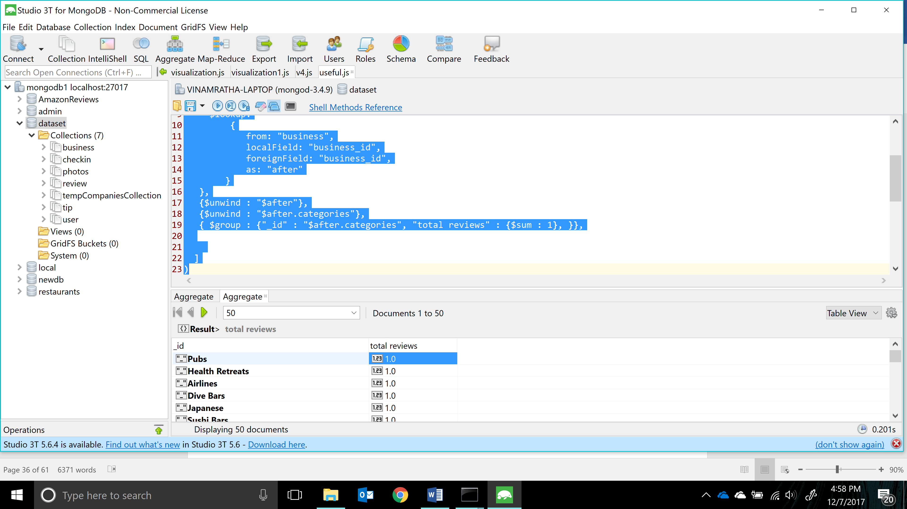

#### Visualization: For Businesses

Below are some metrics which we feel can be used as a means to improve the Yelp website with more visualizations.

1. The below visualization will help the business owner to keep a watch on the restaurants in his neighborhood. The chart shows the number of restaurants in each rating category in his neighborhood.

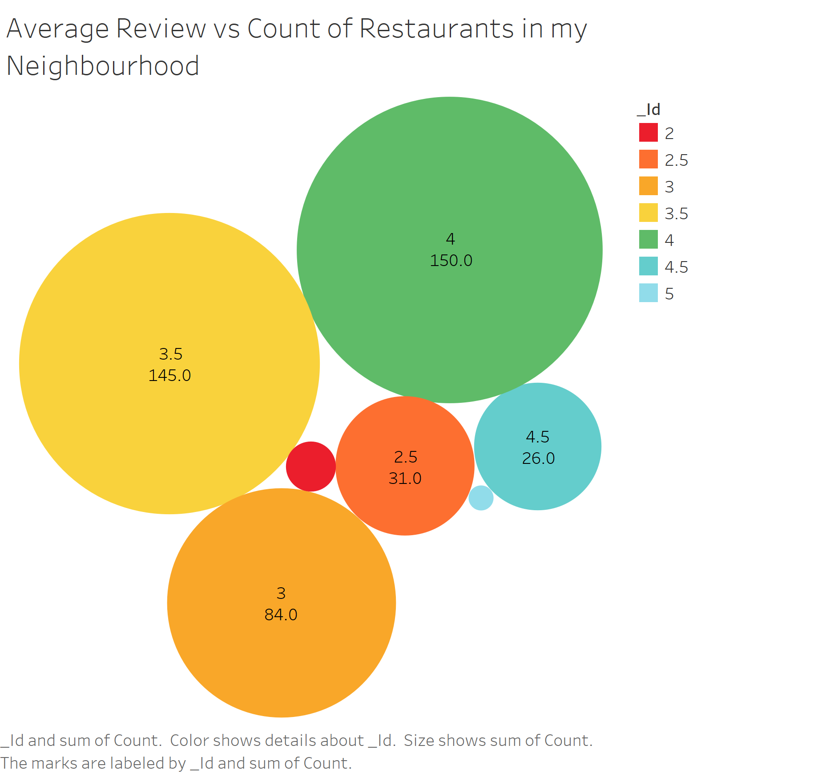

1. When a user visits the page of a business, this below chart shows which neighborhoods in this city have best restaurants. Here as an example we are showing for Las Vegas.

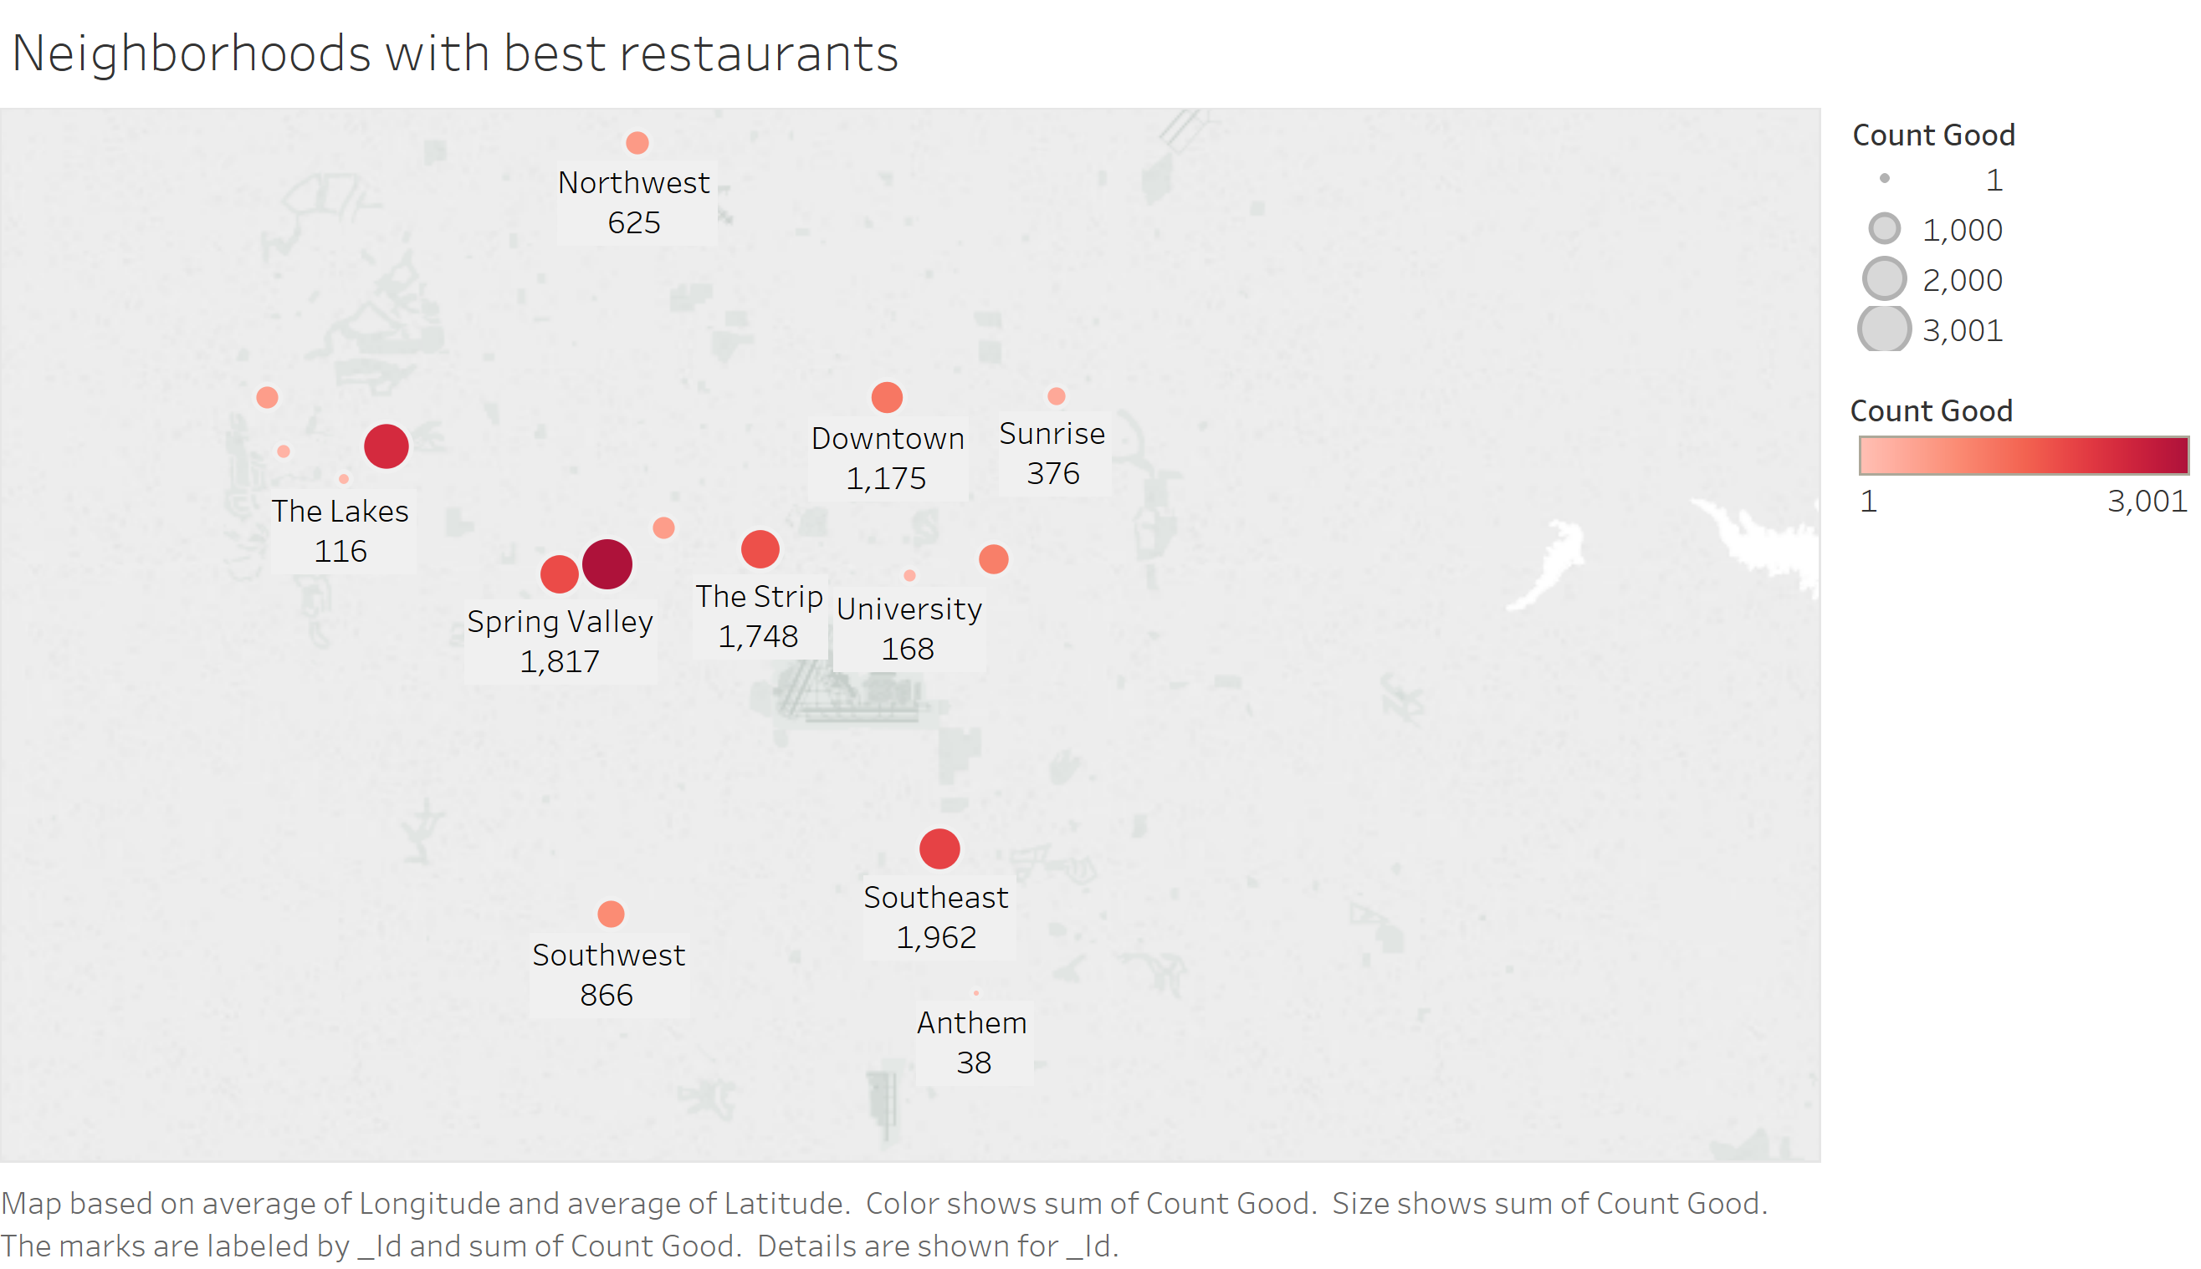

1. The below bar chart shows the business the average number of checkins that have happened at the restaurant at every hour. This will help the business to plan their resources better, be it food supply or man-power.

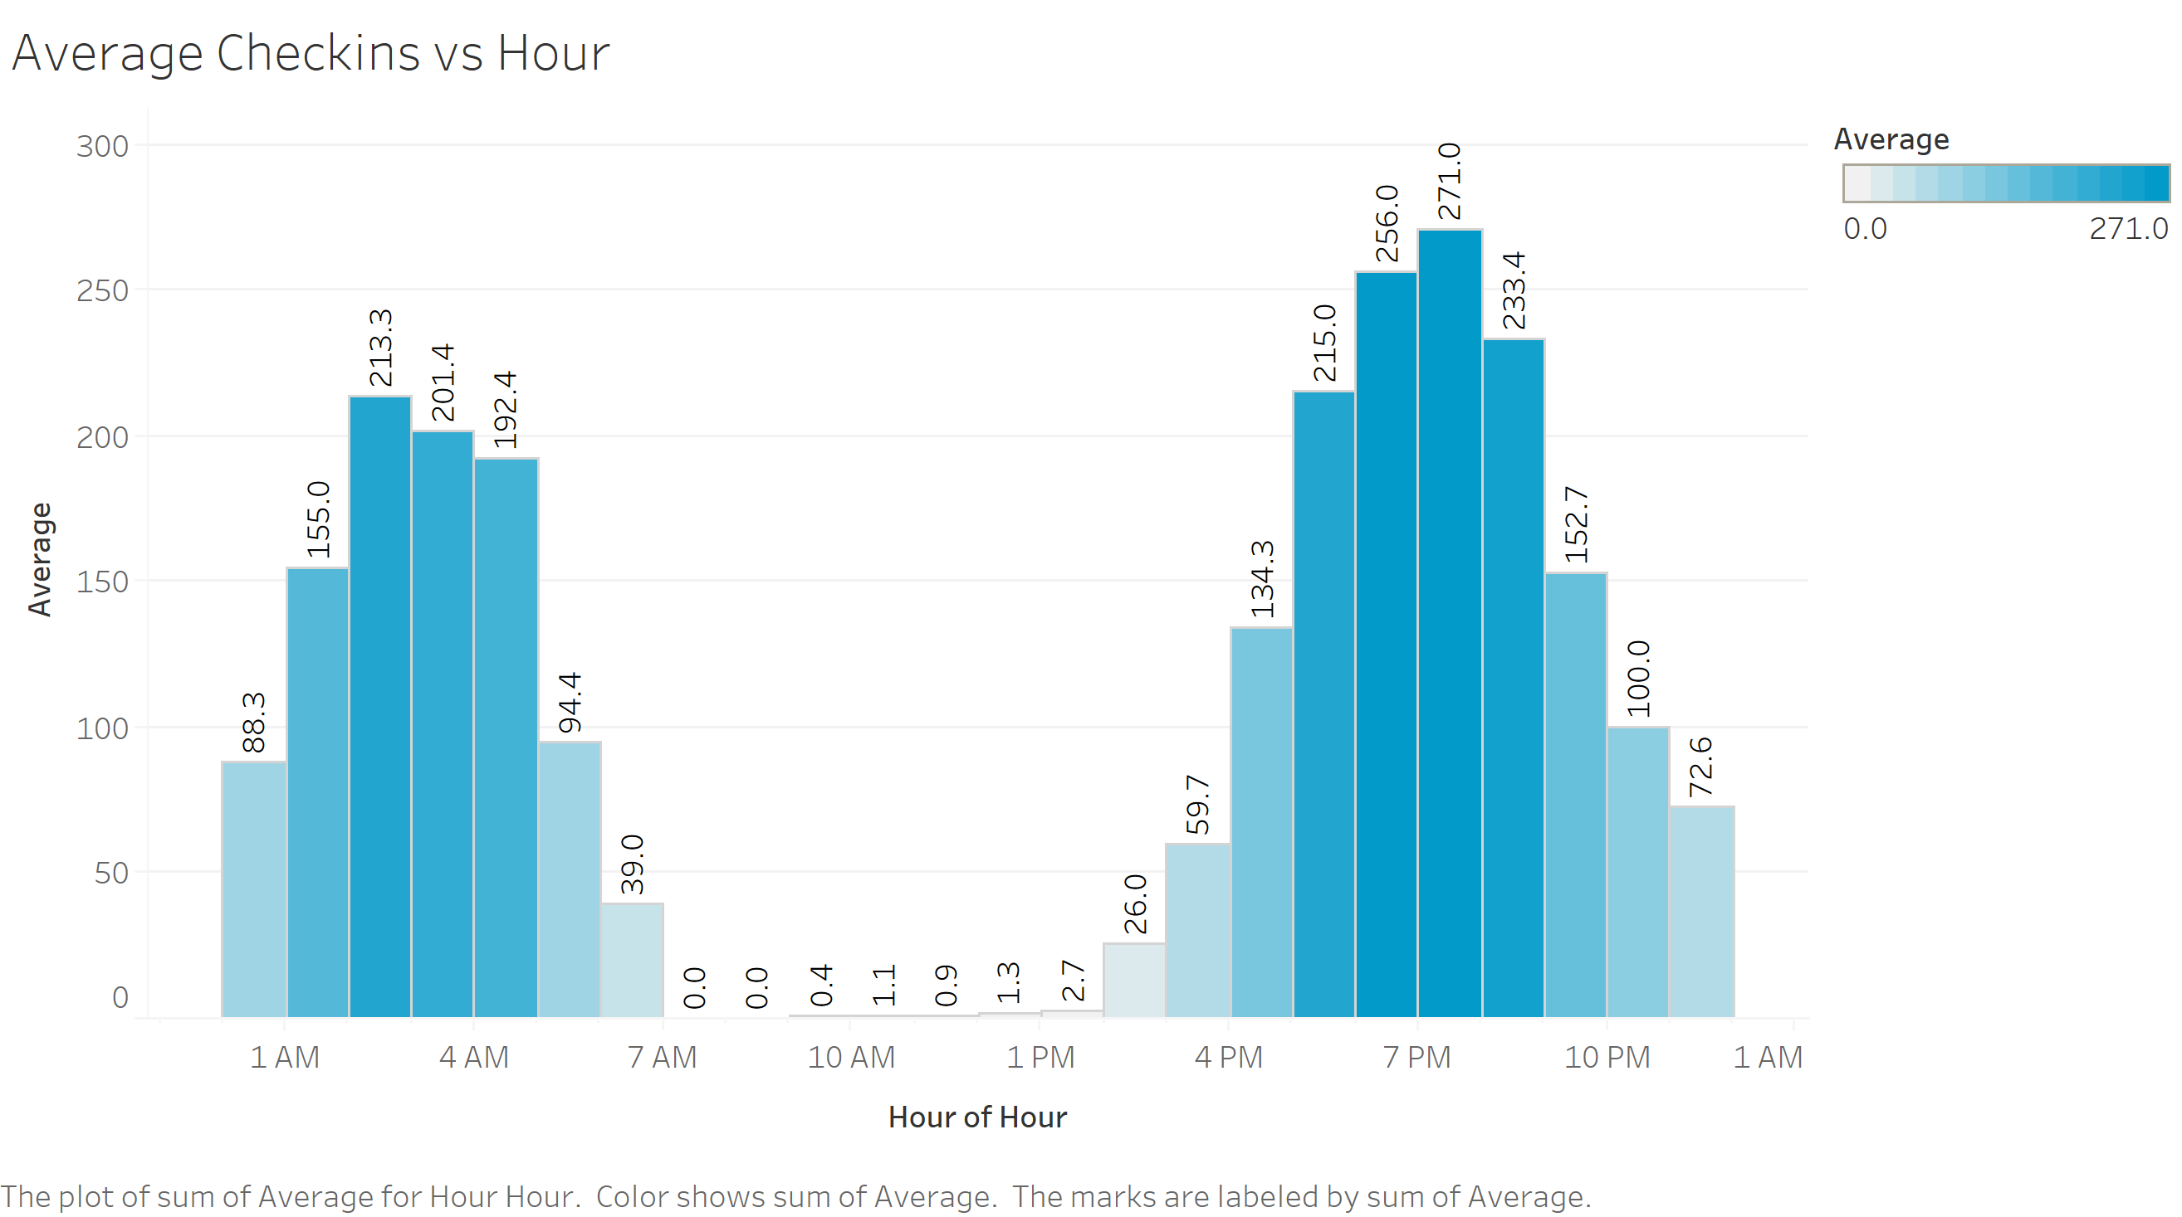

We took the output of this query, modified the way the result s stored in CSV file and then imported to tableau.

1. The below bar chart shows the trend of the business’s ratings and count of business in every star rating over the past 6 months. This helps the business analyze if they are improving in ratings or they need to take some action.

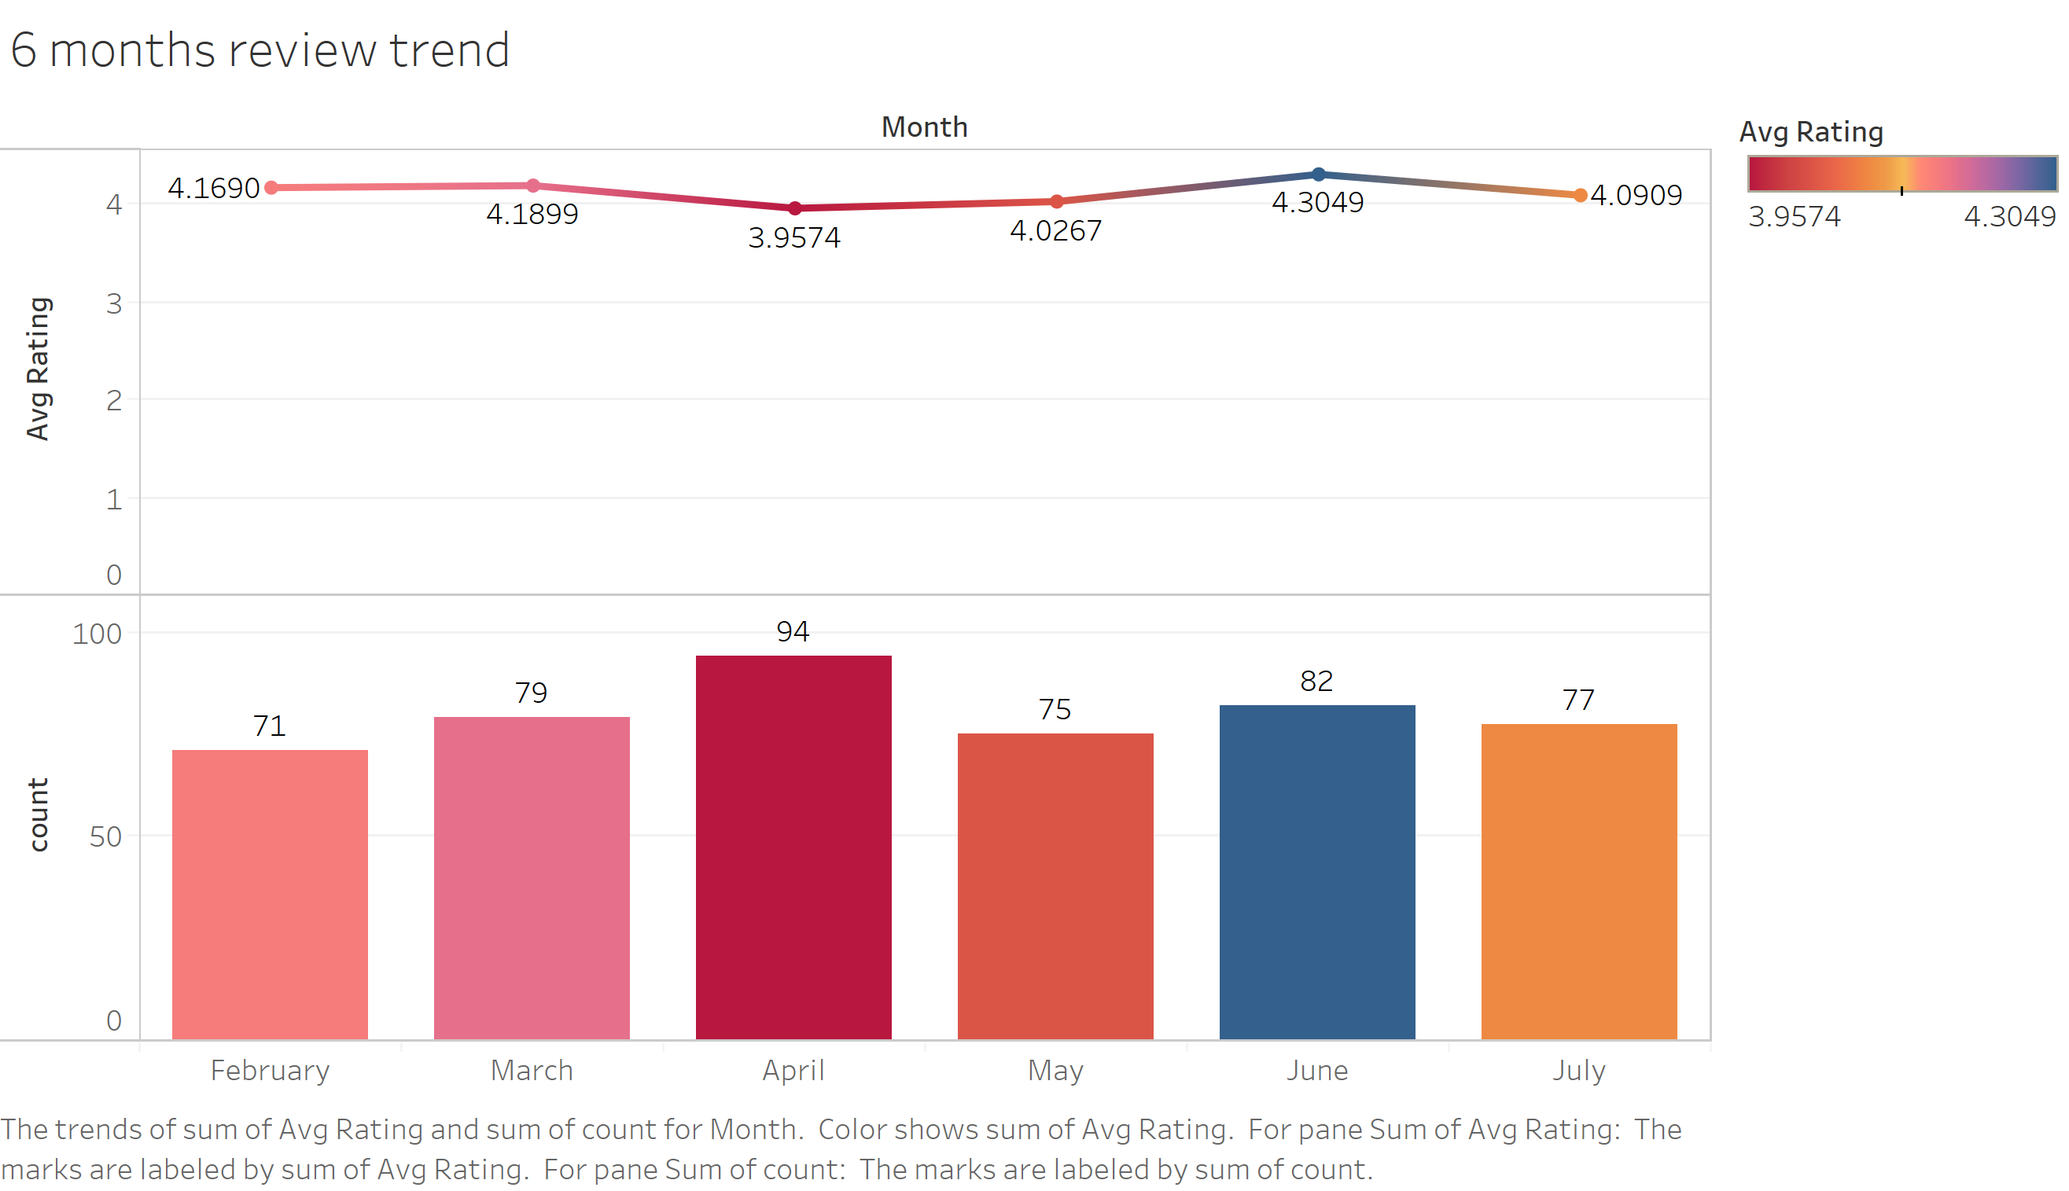

1. This horizontal bar chart shows the latest 100 ratings for the business. This means that the business has visibility of its most recent performance based on recent reviews and ratings.

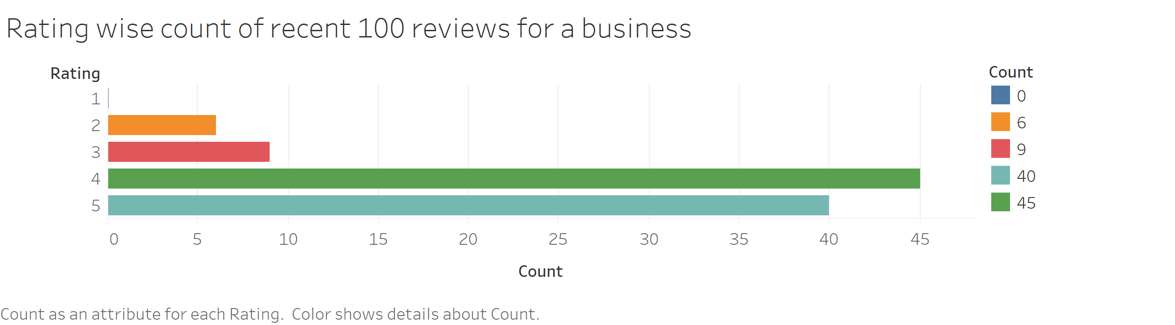

#### Visualization: For Reviewers

1. This below word cloud shows the most common words a reviewer uses in his reviews. When a user visits the page of a reviewer, he can get an understanding of what seems to be important to the reviewer. We have used online tool to create this word cloud

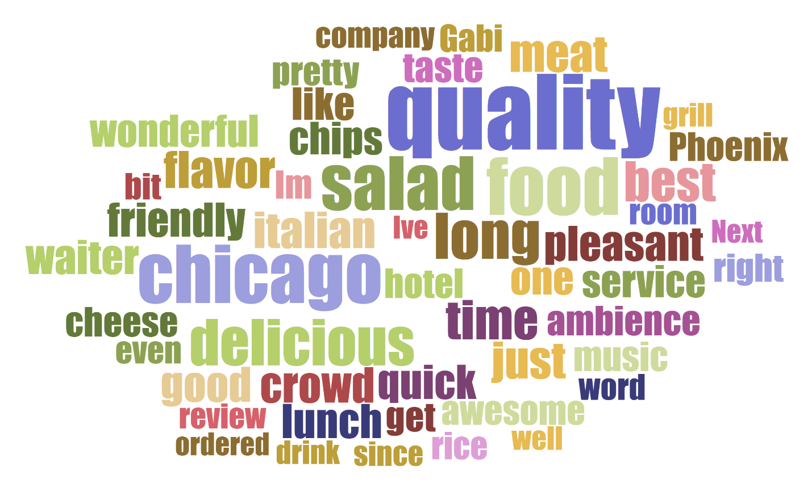

1. The below chart shows the year-wise trend of ratings and count of reviews for a reviewer.

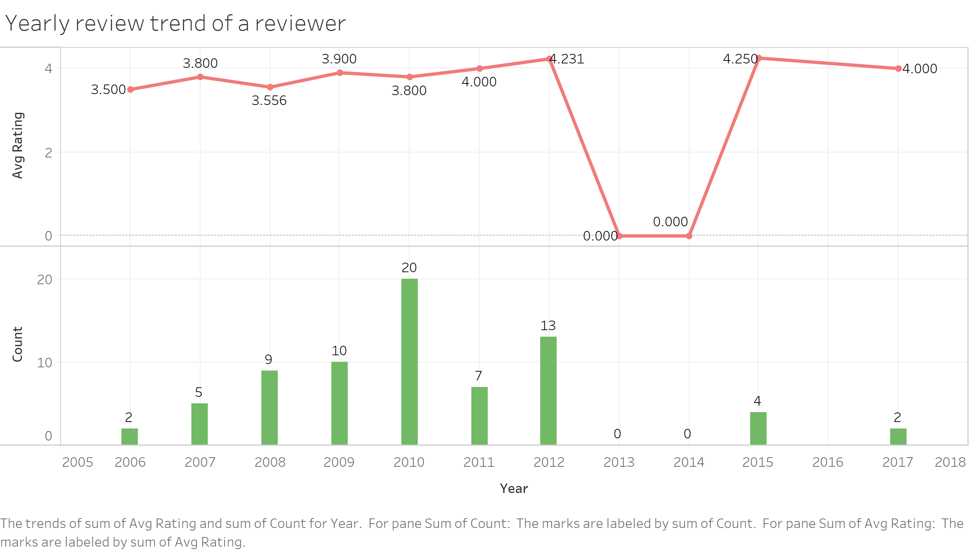

1. The below scatter plot how a reviewers ratings are grouped according to the count of ratings for each star category. Here you can see for the reviewer, most of the ratings close to 4.

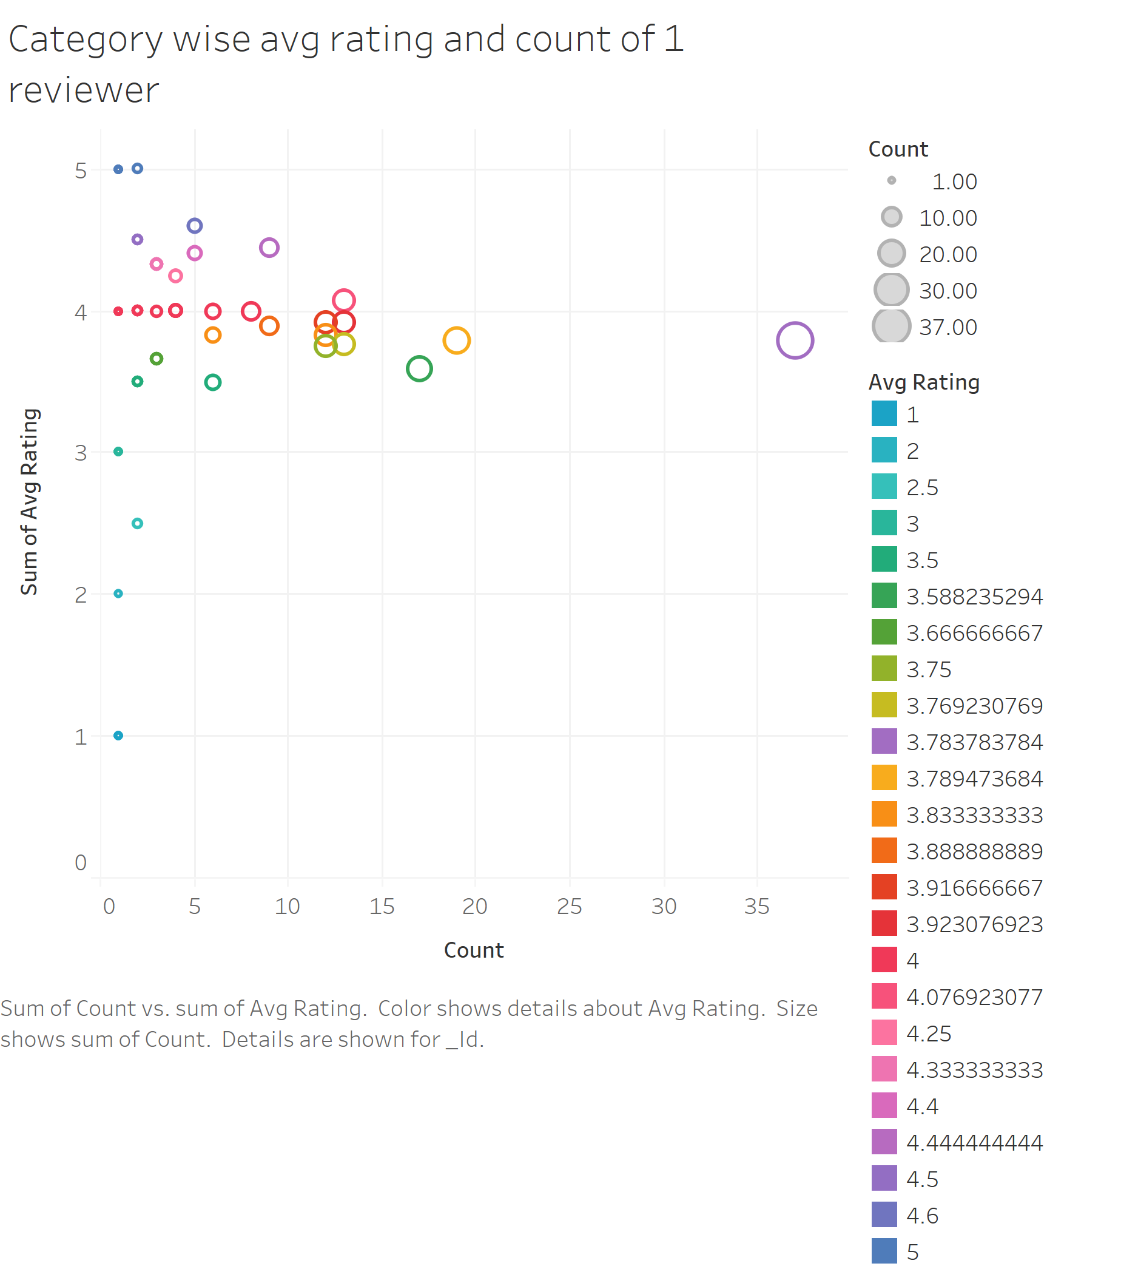

1. The below visualization shows the category wise useful review count of the reviewer. This helps any user identify which category of reviews are most useful.

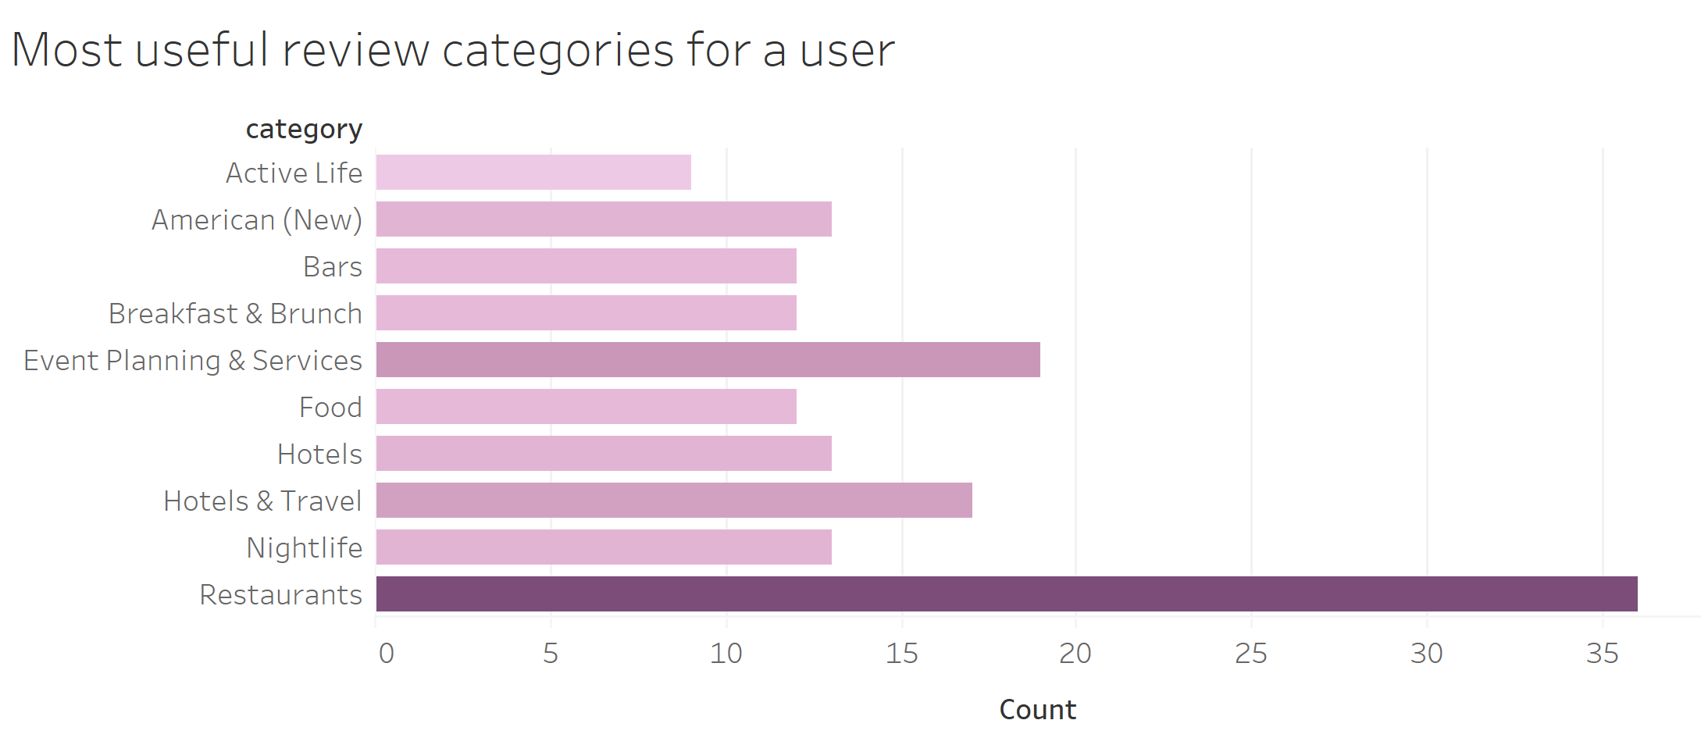

#### Helpfulness analysis using MongoDB

The following analysis identifies helpfulness of Yelp Reviewers

**Non-Text Analysis:**

**Definition of helpful reviews (non-text):** A review marked as useful that is useful not equal to 0 are helpful reviews. Here we are not considering funny and cool field because these fields are not popular among reviewers, not all reviewers mark these fields.

**Query:**

db.review.aggregate(

[

{

$match: {

useful: {

$ne: 0

}

}

},

{

$project:{user_id:1,_id:0 , review_id:1,useful:1,text:1,stars:1}

}

]

)

**Screenshot of Query Execution:**

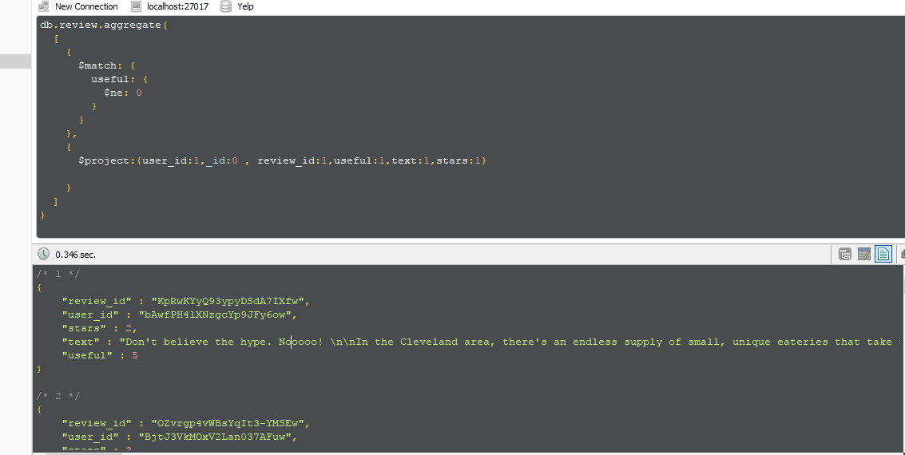

**Summary of Query:**

To get helpful reviews in query we are just matching if useful not equal to 0 and showing result.

**Statistics for helpful reviews:**

|  |  |
| --- | --- |
| Total number of reviews | 4736897 |
| Number of reviewers | 1183362 |
| Number of restaurant | 51613 |
| Total number of helpful reviews for restaurants (non - text) | 1981990 |
| Ratio of helpful reviews to total number of reviews | 41.84% |

**Conclusion:** only 41.84% reviews are marked useful. As these number is low (less than 50%) we can say that it should not be the only criteria for determine whether review is helpful or not.

**Text Based Analysis:**

**Definition of helpful reviews (non-text):**

1. Review text having lots of words are helpful reviews as they provide more details.

**Query:**

db.review.aggregate([

{

$project: {

"_id": 1,text:1,business_id:1,review_id:1,

"length": { $strLenCP: "$text" }

}

}

,{$sort:{length:-1}}

,{$limit:50}

],{allowDiskUse: true});

**Screenshot of Query Execution:**

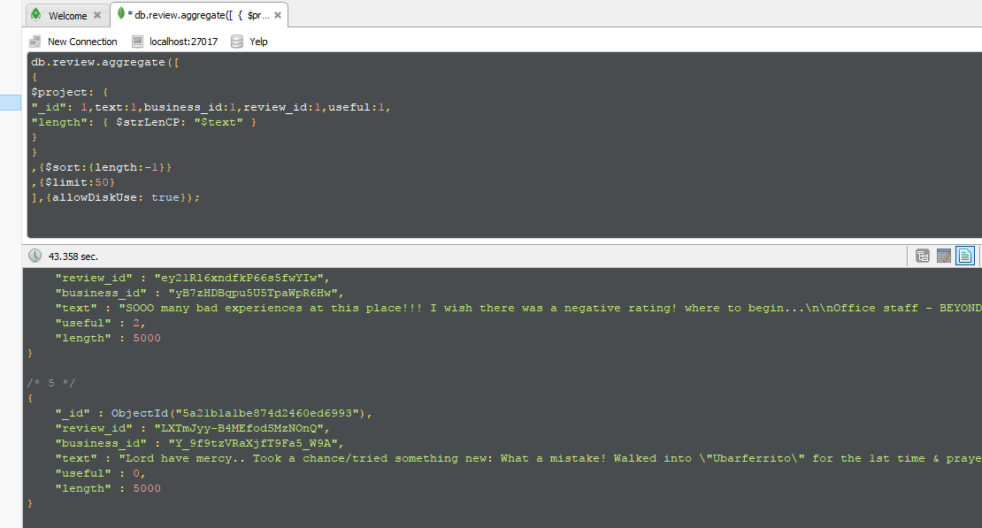

**Summary of Query:**

For getting reviews having lots of words, we calculated length of review text using strLenCP function and sorted result in descending order and showing only first 50 reviews.

1. Review text having key words are helpful reviews as they provide more relevant details.

**Query:**

db.review.aggregate(

[

{$match: {$text:

{$search:"Service food Rice Chicken Bread Salad Vegetables pork beef salmon fish goat noodles crispy stale fresh cheese veggies fries fried kabab naan costly Ambience accommodating snooty helpful informative drab cosy airy vibrant bland uninspiredMouthwatering satisfying value for money rip-off bargain reasonable bettercomparison amazing avoid let down awful abound abounds abundance abundant accessable accessible acclaim acclaimed acclamation accolade accolades accommodative accomodative accomplish accomplished accomplishment accomplishments accurate accurately achievableachievement achievements achievible acumen adaptable adaptive adequate adjustable admirable admirably aspire assurance assurances assure assuredly assuring astonish astonished astonishing astonishingly astonishment astound astounded astounding astoundingly astutely attentive attraction attractive attractively attune audible audibly auspicious authentic authoritative autonomous available aver avid avidly award awarded awards awe awed awesome awesomely awesomeness awestruck awsome backbone balanced bargain beauteous beautiful beautifullly beautifully beautify beauty beckon beckoned beckoning beck believable believeable beloved benefactor beneficent beneficial beneficially beneficiary benefit benefits benevolence benevolent benifits best best-known best-performing best-selling better better-known better-than-expected beutifully classy clean cleaner cleanest cleanliness cleanly clear clear-cut cleared clearer clearly clears clever cleverly cohere coherence coherent cohesive colorful comely comfort comfortable comfortably courteous courtly covenant cozy creative credence credible crisp crisper cure cure-all cushy cute cuteness danke danken daring daringly darling dashing dauntless dawn dazzle dazzled dazzling dead-cheap dead-on decency decent decisive decisiveness dedicated defeat defeated defeating defeats defender deference deft deginified delectable delicacy delicate delicious enthral enthrall enthralled enthuse enthusiasm enthusiast enthusiastic enthusiastically entice enticed enticing enticingly entranced entrancing entrust enviable enviably envious enviously enviousness envy equitable ergonomical errfree erudite ethical eulogize euphoria euphoric euphorically evaluative evenly eventful everlasting evocative exalt exaltation exalted exaltedly well-educated well-established well-informed well-intentioned well-known well-made well-managed well-mannered wellpositioned well-received well-regarded well-rounded well-run well-wishers Ridiculous Robbed Rotten Ruthless Sad Sadistic Sarcastic Scared Scarred Scary Screwed Screwed over Screwed up Secretive Sensitive Shouted at"}}},

{$project: {"review_id":1, "_id":0,"score": {$meta:"textScore"}}},

{$group: {"_id":"$review_id", "count":{"$sum":"$score"}}},

{$sort: {"count":-1}},

{$limit:10}

]

)

**Screenshot of Query Execution:**

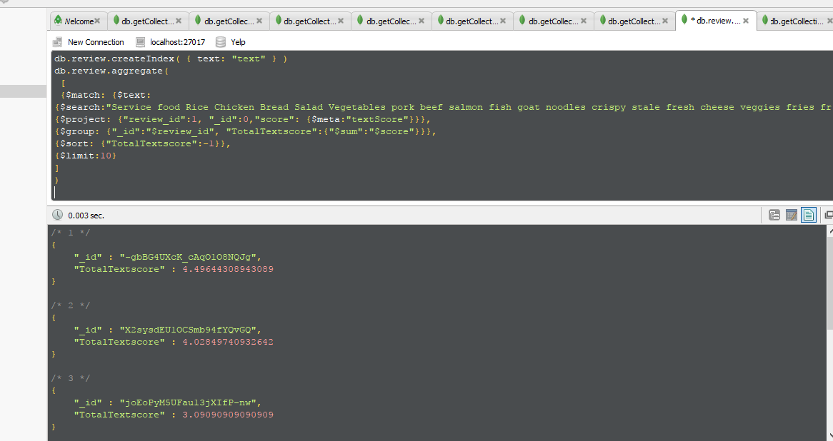

**Summary of Query:** We have defined our own dictionary of key words. Dictionary has restaurant, food menu related words, positive and negative words. We have referred following online resources to form our own dictionary. <http://dreference.blogspot.com/2010/05/negative-ve-words-adjectives-list-for.html>

<http://positivewordsresearch.com/list-of-positive-words/>

<http://www.wjh.harvard.edu/~inquirer/homecat.htm>

**Due to memory constrain** we have included only few words from our dictionary in the query. AS you can see above in Query, we have searched these keywords in review text and calculated text score for review, sum score of all words for a review then sorted result in descending order to get most helpful review

**Conclusion:** Reviews which are helpful based on their text are not always marked useful. There are reviews which are marked as useful but not all.

**Comparison of Text and Non-Taxed based helpfulness:**

**Question:** Are the textbased and the non-text based approaches in agreement on results

**Answer**: No.

**Reason**:

1. All users have different perspective so a review useful for any user may not be useful for another user. Hence not all useful marked reviews are useful when we consider text of review.
2. Text based analysis is considering only text of reviews, so it is also not 100% correct from user’s perspective as everyone looks for different key words.
3. Better approach to find helpfulness of reviews can be combination of both text and non-text based definitions. That is reviews which are helpful based on their text and are also marked useful.

### b) Using SAS

**Objective:** Identify fake reviews based on the review text for Yelp reviews dataset.

**Input File:**

Input file is sas data set (. sas7bdat) file. Yelp reviews data set which is in json format is converted to sas data set in SAS enterprise guide. Input file has parameters- text, review Id, business Id, User Id for all the Yelp reviews.

|  |  |
| --- | --- |
| **Column** | **Description** |
| review_id | Id of the review |
| business_id | Id of the business for which review is given |
| text | Text of the review |
| user_id | User id of the reviewer who has given review |
| _id | Unique Id for each review |

One review document in input file looks like as follows –

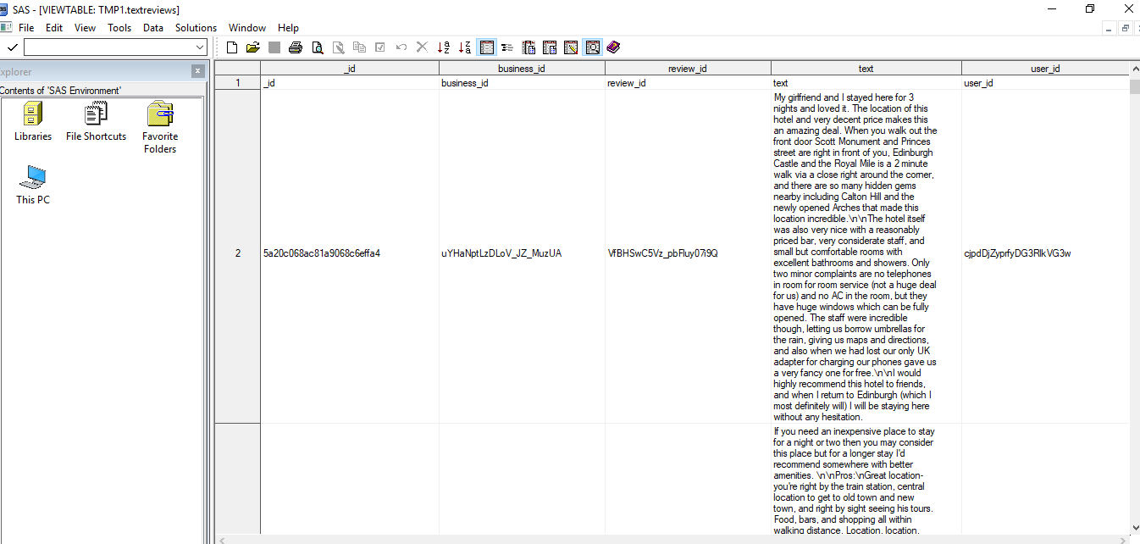

Data source is created from this input file where review text is a text and review Id, business Id, User Id are the IDs.

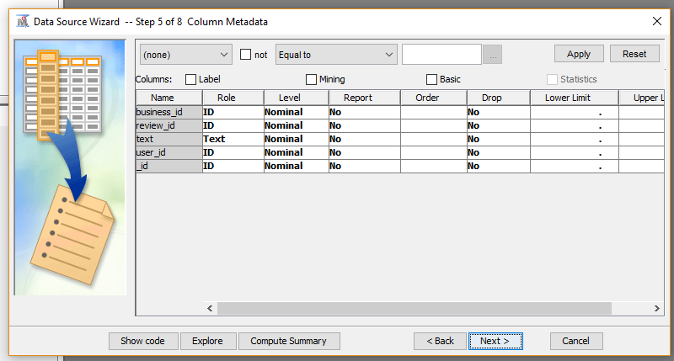

**Text Mining Using SAS:**

**Workflow Diagram:**

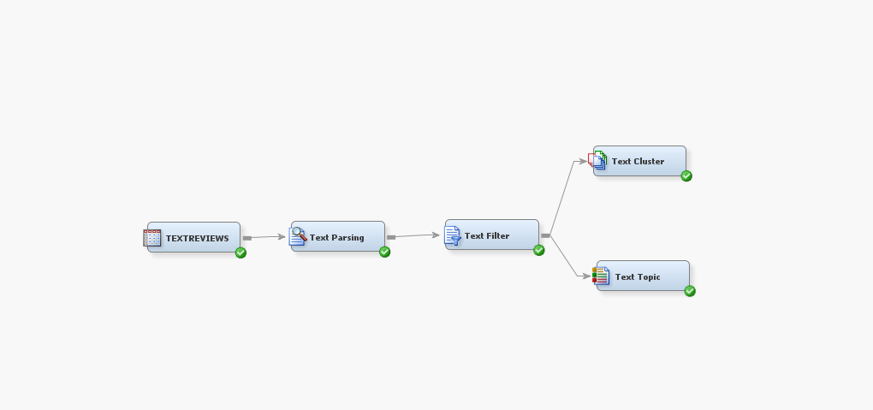

**Parameters and dictionaries for text parsing:**

1. Attributes – considering only alpha and mixed type and number, punctuations and abbreviations are ignored
2. Parts of Speech – considering only noun, adjectives, adverbs, verb, verb adjective in the review text and Ignoring the preposition (e.g. on, at, under, between), conjunction (e.g. and, or, but, after), auxiliary verbs (e.g. had, been, have), interjections (e.g. oh, hey), determiner (e.g. this, that, the)
3. Entities – Most of entities are parsed as proper noun so find entities property changed from none to standard.
4. Stop List – Used default stop list provided by SAS miners few words included in stop list are – again, ago, above, abroad, accordingly, according, among, along
5. Start List - we have included all the adjectives, adverbs and food restaurants related terms in list few examples are – good, horrible, great, menu, ambience, space, bad, awesome, beautiful etc.

Word dictionary is formed with the help of word list from following online resources –

<http://dreference.blogspot.com/2010/05/negative-ve-words-adjectives-list-for.html>

<http://positivewordsresearch.com/list-of-positive-words/>

<http://www.wjh.harvard.edu/~inquirer/homecat.htm>

**Steps:**

1. **Text Parsing**

On the data source created above we have connected text parsing node to parse the review text.

It helps to parse document text so that we can quantify the required information.

Excluding terms which are not required using text parsing property panel

Text parsing result for the review text can be seen in below report –

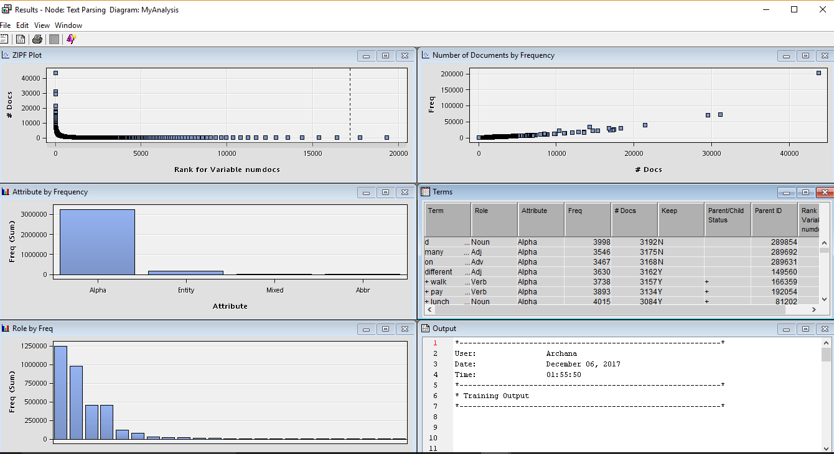

1. **Text Filter**

We can filter some text which creates noise for our analysis. Result of the text filter is as follows, It can be seen that only terms required for analysis are kept and rest are dropped.

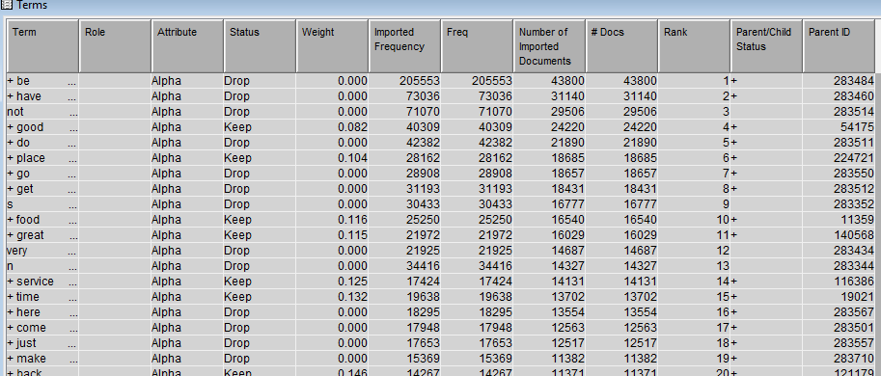

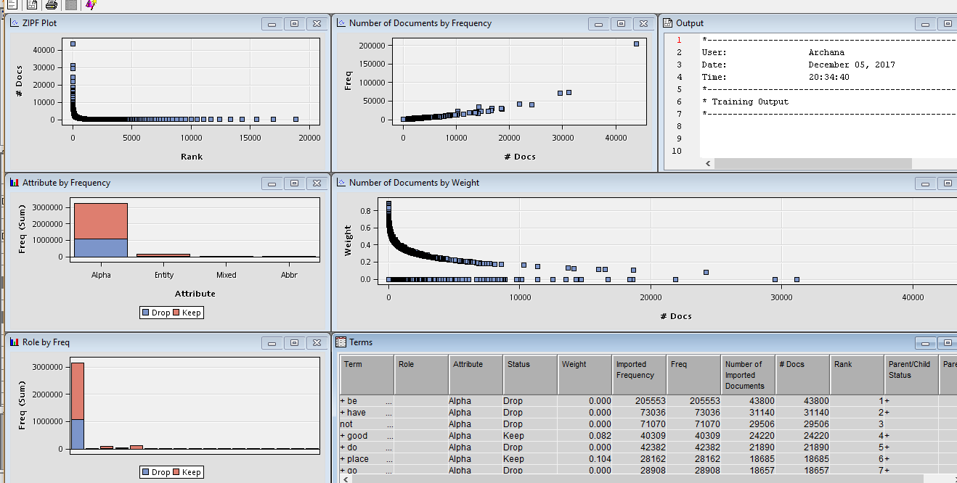

1. **Text Cluster**

The Text Cluster node is clustering documents into disjointed sets of documents and reports on the descriptive terms for those clusters. In this analysis, review text is clustered in to 20 clusters. Clusters are reported as –

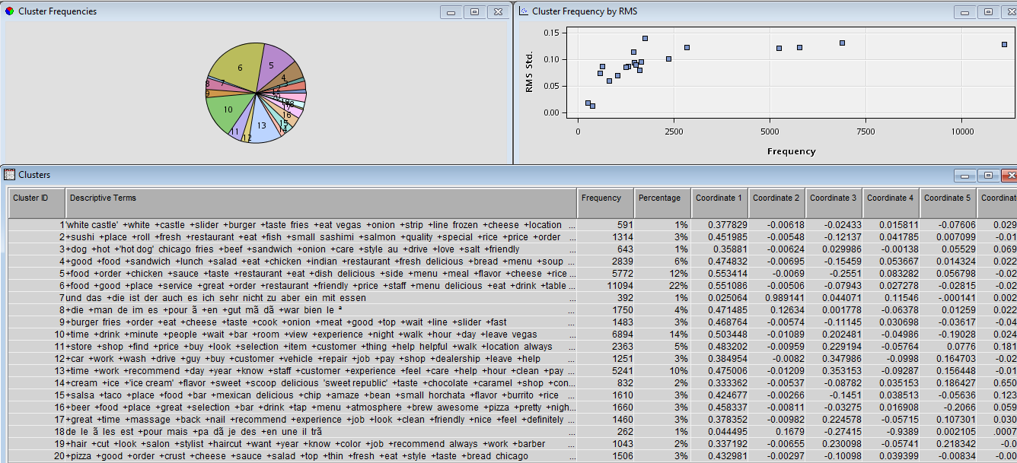

It can be concluded from the above result that cluster 6 having terms +food +good +place +service +great +order +restaurant +friendly +price +staff +menu delicious +eat +drink +table +food +good +place +service +greathas highest frequency 22% percentage.

1. **Text Topic**

It is creating a list of topics is to establish combinations of words that are interested in analyzing. Combine individual terms into topics to improve text mining analysis. By combing analyzing specific groupings of words in review text.

Result of Text Topic is –

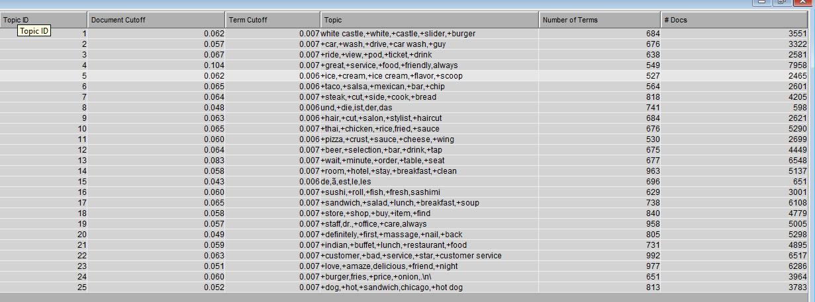

**Identifying fake reviews using SAS text mining:**

In analysis, we are considering Topic Id, number of terms and Documents and cluster Id for reviews from text cluster and text topic derived from above steps using SAS text miner.

1. **Definition of fake reviews**:

Topics where number of terms are higher than number of documents.

From Text topic analysis, we can say that these reviews can be fake so in above (Text Topic) report for Topic Id 15 and 8 number of terms are higher than documents, so they are fake reviews.

1. **Definition of fake reviews**:

Reviews in which topic terms are less means reviewer is writing more irrelevant words and giving reviews either 5 or 1. Review text has less number of topic terms.

Apart from Topic 15 and 8 if we further analyze reviews only in then we have Topic Id 5 where number of terms are very less compare to other topics. So, to identify fake reviews, we are concentrating on these reviews.

Topic Id 5 has terms - +ice,+cream,+ice cream,+flavor,+scoop

This means in review text these terms are less and reviewer has written more irrelevant terms or words.

Analysis of reviews in Topic Id 5 - Text Cluster report shows that cluster id for this ice cream restaurants is 14. Hence let’s analyze these reviews in textcluster_train sas data file created when we run text cluster on our reviews.

For cluster id 14 we can see few sample reviews –

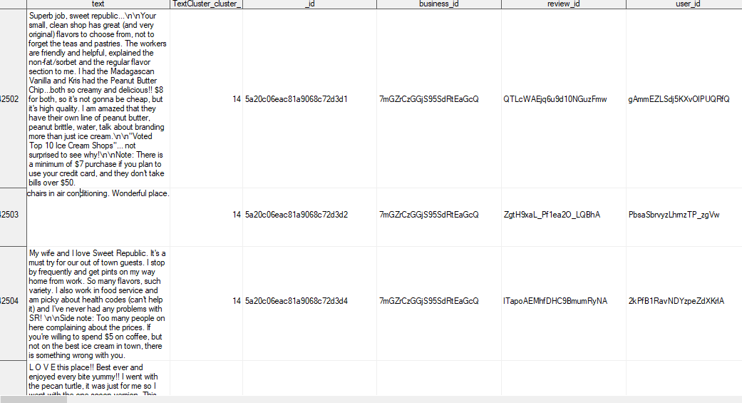

**Conclusion:** When we analyze these reviews, we observed that almost all reviews have rating 5 and few have rating 1 and lots of positive words are used but these are not topic terms. Hence, we can conclude that these can be fake reviews.

### Using Neo4J

#### SETTING UP NEO4J ENVIRONMENT

## **Create 3 Node types:**

1. User
2. Business
3. Reviews

using periodic commit

LOAD CSV with headers from 'file:///reviewTorNew.csv' as yelp

MERGE (user:user { userId:yelp.user_id})

MERGE (Business:Business { businessId:yelp.business_id})

MERGE (review:review { reviewId:yelp.review_id})

## **Create Properties of the Node:**

set user = {userId:yelp.user_id}

set Business = {businessId:yelp.business_id}

set review = {reviewId:yelp.review_id,date:yelp.date}

## **Create relationships:**

CREATE (Business)-[:Has_Reviews]->(review)

CREATE (user)-[:Writes]->(review)

CREATE (user)-[:Reviews]->(Business)

## **Create Indexes:**

CREATE INDEX ON :Business(businessId)

CREATE INDEX ON :Business(city)

CREATE INDEX ON :user(userId)

CREATE INDEX ON :review(reviewId)

CREATE INDEX ON :review(date)

## **Create Constraints:**

CREATE CONSTRAINT ON (Business:businessId) ASSERT Business.businessId IS UNIQUE;

CREATE CONSTRAINT ON (review:reviewId) ASSERT review.reviewId IS UNIQUE;

CREATE CONSTRAINT ON (user:userId) ASSERT user.userId IS UNIQUE;

|  |  |
| --- | --- |
| Reviewers sometimes review as a mob (reviewing the same set of businesses  over and over). Do you find this behavior in this dataset?  Run the queries and derive the results. | **Summary** |
| MATCH (u1:user)-[:Reviews]->(b:Business)<-[:Reviews]-(u2:user),  (b)-[:Has_Reviews]->(r1:review)<-[:Writes]-(u1:user),  (b)-[:Has_Reviews]->(r2:review)<-[:Writes]-(u2:user)  Where r1.date=r2.date  With u1,u2, collect(Distinct b.businessId) as businesses, count(Distinct b.businessId) as cntbus, r1.date as r1date  With businesses, Collect(Distinct u1.userId) as Users,count(Distinct u1.userId) as cntUser,cntbus, r1date  where cntbus>1  RETURN businesses,Users,cntUser, r1date,cntbus  Order By cntUser Desc | **Yes, we found this behavior in the dataset we analyzed. We found several Mobs who reviewed same type of businesses over and over again.**  We derived the flowing logic of trace the mob in the dataset:  Identify a Mob- A mob is a group of persons who review same type of businesses on the same date. To arrive at the result, we have 2 steps in our analysis.  Check 1: Derive the set of Reviewers who have reviewed same set of businesses more than once.  Check 2: If the review is done on the same date of those businesses.  Result: If both Check 1 and Check 2 both are satisfied, we mark such set of users as mob. |

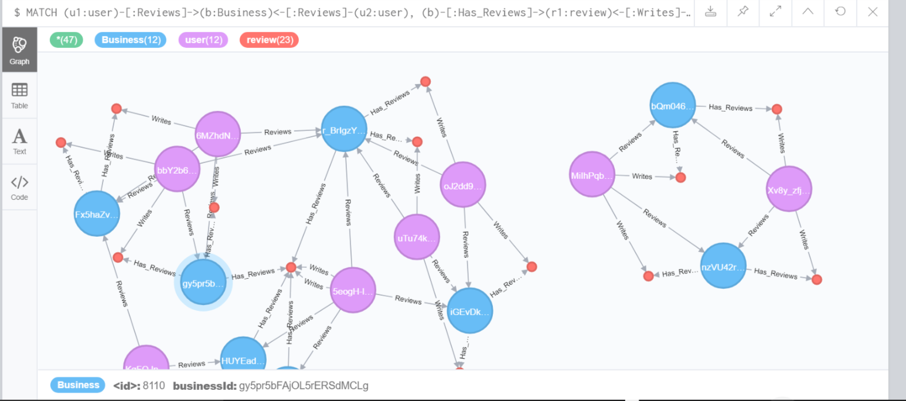

Table format: - Here we can see array of users reviewing the array of businesses on the same date.

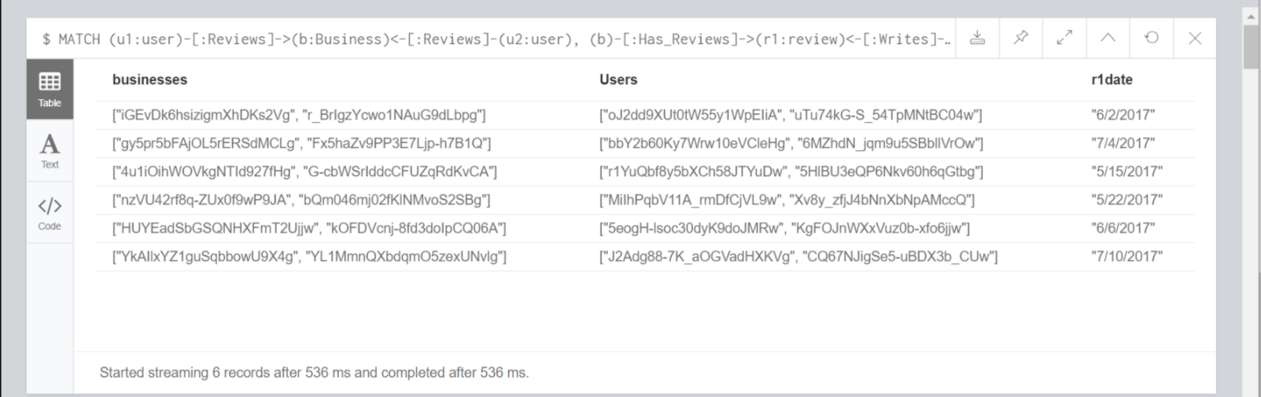

Output: 6 Mobs identified in Toronto City for Year 2017 Data.

In the selected data sample (One city for few months, filtered due to memory issue), we found that 6 mobs are reviewing same business on same date. Hence, we term these 6 groups as MOB reviewers.

|  |  |
| --- | --- |
| Reviewers sometimes review as a mob (reviewing the Does geographical proximity lead to uniformity in business ratings or divergence?  Run the queries and derive the results. Explain your findings. | **Summary** |
| MATCH (n:Business),(m:Business)  Where n<>m and n.postalcode in ["M5B 2H1", "M5V"]  and m.postalcode in ["M5B 2H1", "M5V"]  WITH point({ longitude: n.longitude, latitude: n.latitude }) AS startPoint, point({ longitude: m.longitude, latitude: m.latitude }) AS endPoint,n,m  With ID(n) as ClusterID,n.businessId as nBusiness, m.businessId as mBusiness,round(distance(startPoint, endPoint)) AS travelDistance,n.stars as nstars,m.stars as mstars  Where (travelDistance < 1000)  //Section 1  With Distinct ClusterID,collect(mBusiness) as NearBy,collect(mstars) + nstars as collectionOfRatings,count(mBusiness)+1 as NearbyCount,(sum(mstars)+nstars)/(count(mBusiness)+1) as Average  //Section 2  Unwind collectionOfRatings as c  with ClusterID,(c-Average)*(c-Average) as num1,Average,NearbyCount  with ClusterID,sum(num1) as num2,NearbyCount,Average  with ClusterID,num2/(NearbyCount-1) as num3,NearbyCount,Average  return ClusterID as ProximityCluster,sqrt(num3) as StandardDeviation,NearbyCount as TotalBusinesses  order by NearbyCount desc | The geographical proximity did not show any pattern of uniformity of rating in the dataset we analyzed.  Logic:  We did not take Zip code as the proximity factor as two businesses belonging to same zip code may have more distance from each other than the restaurants in the neighboring zip codes at the adjoining border. We considered Longitude and Latitude and got the Cartesian product of all the Businesses which are close to each other by 1000 meters (Configurable in query).  The distance is calculated using distance() function of Neo4J framework.  Distance wise (businesses within 1000 square meters) clusters are created and rating in each cluster is compared using Standard Deviation. |

|  |  |
| --- | --- |
| Reviewers sometimes review as a mob (reviewing the Does geographical proximity lead to uniformity in business ratings or divergence?  Run the queries and derive the results. Explain your findings. | Summary  (Query 2 written to give an over all Uniform/Distributed output in the analysis) |
| MATCH (n:Business),(m:Business)  Where n<>m and n.postalcode in ["M5B 2H1", "M5V"]  and m.postalcode in ["M5B 2H1", "M5V"]  WITH point({ longitude: n.longitude, latitude: n.latitude }) AS startPoint, point({ longitude: m.longitude, latitude: m.latitude }) AS endPoint,n,m  With ID(n) as ClusterID,n.businessId as nBusiness, m.businessId as mBusiness,round(distance(startPoint, endPoint)) AS travelDistance,n.stars as nstars,m.stars as mstars  Where (travelDistance < 1000)  //Section 1  With Distinct ClusterID,collect(mBusiness) as NearBy,collect(mstars) + nstars as collectionOfRatings,count(mBusiness)+1 as NearbyCount,(sum(mstars)+nstars)/(count(mBusiness)+1) as Average  //Section 2  Unwind collectionOfRatings as c  With ClusterID,(c-Average)*(c-Average) as num1,Average,NearbyCount  With ClusterID,sum(num1) as num2,NearbyCount,Average  With ClusterID,num2/(NearbyCount-1) as num3,NearbyCount,Average  With ClusterID,sqrt(num3) as StandardDeviation,NearbyCount as TotalBusinesses  Return count(ClusterID) as Clusters, CASE When StandardDeviation < 0.70 Then "Uniform Rating" Else "Distributed Rating" End as Analysis | The Query is similar as explained above in calculating Standard Deviation of each cluster derived for geography proximity.  However, this data is grouped and the case accepted is if StandardDeviation of a cluster is < 0.70 then we mark the cluster as "Uniform Rating" else we mark the cluster as "Distributed Rating".  All the clusters are summed-up to get the proportion and it was derived that 97 clusters out of 103 had distributed data.  6 out of 103 had uniform data.  Therefore, it is concluded that the rating is not-uniformly given but is distributed without any effect of the geographical proximity. |

**Output of query 1 (Partial View)**

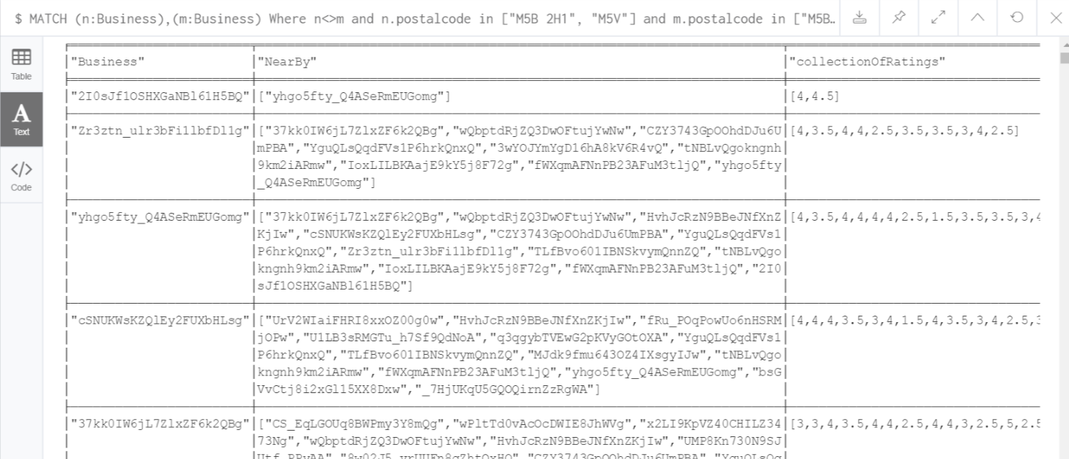

**Output of query 1 (Complete View)**

Column “ProximityCluster” is auto-created by system for businesses within 1000 square meters of radius.

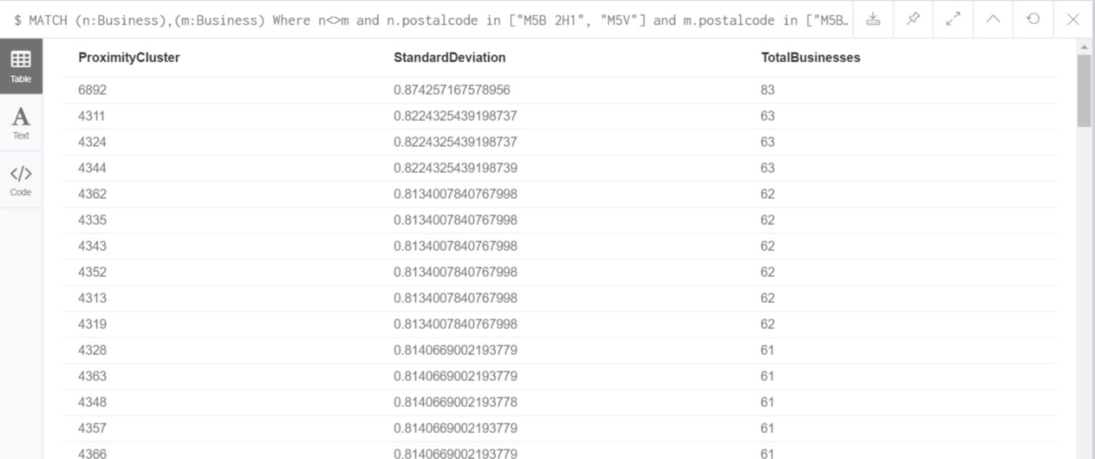

**Output of query 2**

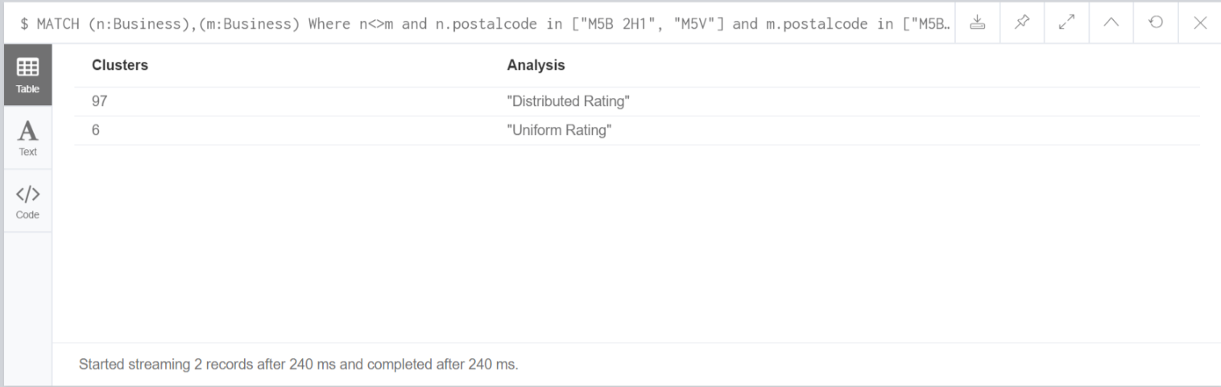

## Validate Output with Excel and Google Maps

**What we wanted to validate:**

We wanted to validate if the clusters are correctly getting created and it contains only those businesses which are within 1000 square meters distance.

We took sample data from out output and studied it in excel using filters.

**Sample Date:**

3wYOJYmYgD16hA8kV6R4vQ and Zr3ztn_ulr3bFi1lbfDl1g are put into same cluster of size 1000 meters.

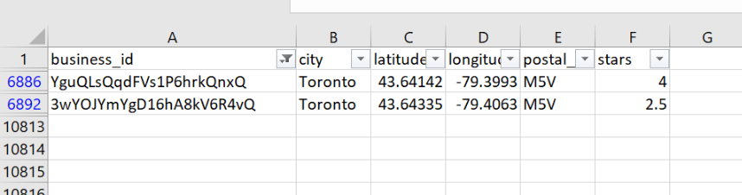

Checking location proximity of 2 Businesses which mere modelled in a common cluster by our program:

3wYOJYmYgD16hA8kV6R4vQ = (43.64335, -79.4063)

YguQLsQqdFVs1P6hrkQnxQ = (43.6360817, -79.4028854)

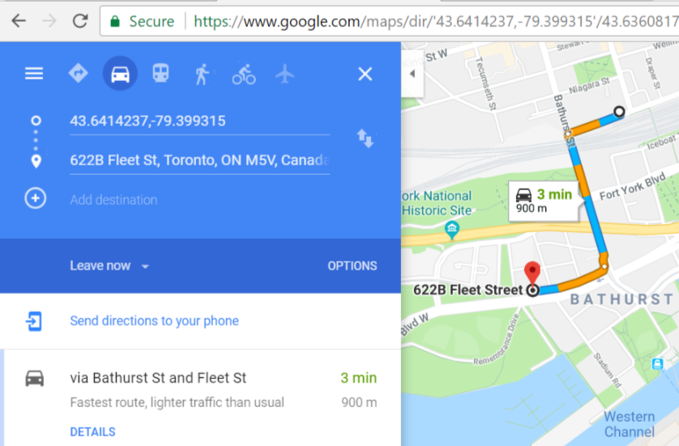**Validation Successful**:

The model found to be working correct. The proximity of the cluster in the query is set as 1000 Square meter and the businesses were 900 m away.

#### Business Page Redesigned

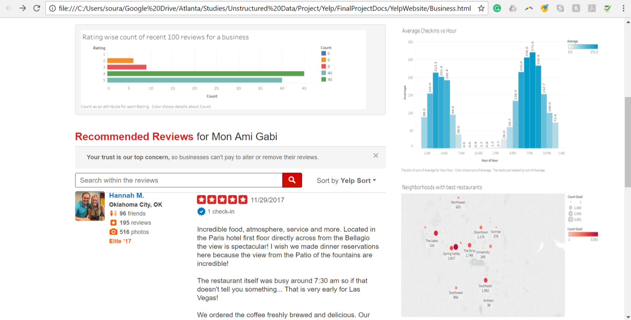

This is the sample webpage for ‘business’ which we have created by adding some useful metric. In addition to what is already being displayed presently on Yelp Website, adding the above information would help user in decision making, and help business to analyze its performance.

#### Reviewer Page Redesigned

#### 

This is the sample webpage for ‘user’ which we have created by adding some useful metric. In addition to what is already being displayed presently on Yelp Website, we have added review trends for a user based on count of reviews and average rating the user provides to the businesses. This would help businesses and other users to gain perspective about this user that would in turn help them in decision making.